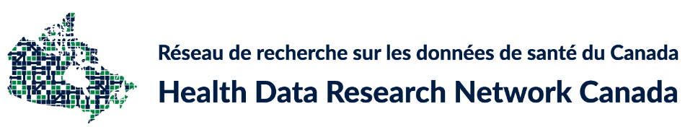

SOCIAL LICENCE FOR USES OF HEALTH DATA:
A REPORT ON PUBLIC PERSPECTIVES
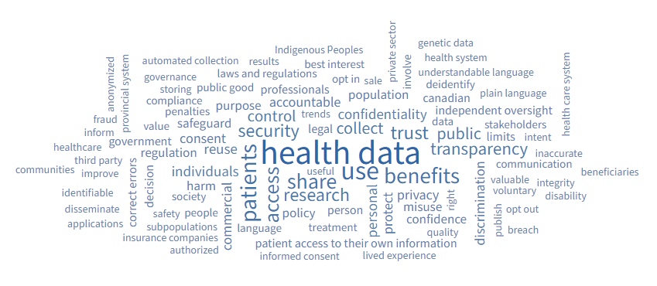

Julia Burt,¹ Annabelle Cumyn,^{2 ,3} Roxanne Dault,² P. Alison Paprica,^{1,4} Christian Blouin, Paul Carter, Brian Cho, Carrie Costello, Clara Dallaire, Martin Dawes, Marc Desrosiers, Annie-Danielle Grenier, Frédérick L’Hérault, Alies Maybee, Shirley Morrison, Shaneel Pathak, Danièle Remy Lamarche, Robert Olivier, Juanna Ricketts, Ginette Saucier, Ilse Tack, Eva Villalba, Raymond Vles, Mike Warren
___________________________
This work was funded by the Public Health Agency of Canada to support the development of the Pan-Canadian Health Data Strategy. The analyses, conclusions, and statements expressed in the report are those of the authors, and not necessarily those of the Public Health Agency of Canada.

1 Health Data Research Network Canada (HDRN Canada) / Réseau de recherche sur les données de santé du Canada (RRDS Canada)
2 Interdisciplinary Research Group in Health Informatics, University of Sherbrooke/ Groupe de recherche interdisciplinaire en informatique de la santé. (GRIIS), Université de Sherbrooke
3 Author to whom French language communications should be sent to at annabelle.cumyn@USherbrooke.ca
4 Author to whom English language communications should be sent to at alison.paprica@utoronto.ca

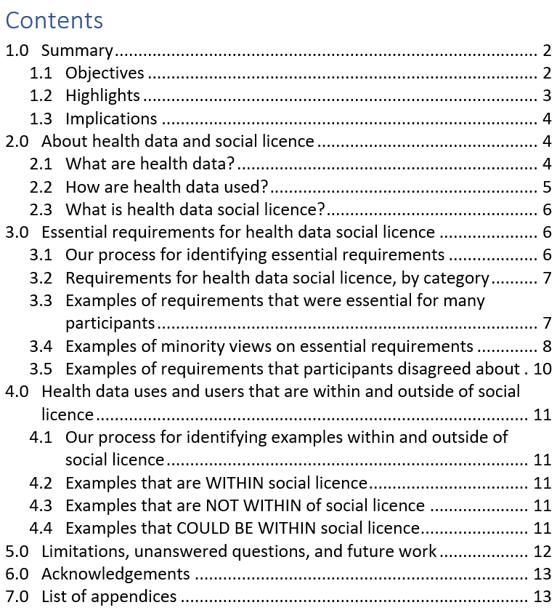
1.0 Summary

1.1 Objectives
In the last decade, multiple research studies and reports have come to the same conclusion: many members of the public support health data being used, shared, and reused for public benefit, but only if their concerns related to privacy, commercial motives, equity and fairness are addressed. Increasingly, these studies and reports use the term “social licence” to describe which uses and users of health data members of the public support, and under what conditions.
The aim of this report is to complement and build upon the findings from prior studies and reports by adding:
- Experienced public and patient advisors’ views about essential requirements for a use or user of health data to be within social licence
- Specific examples of health data uses and users that participants agreed are within or outside of social licence
- Attention to the views of individuals who have different needs and expectations than most other people (which may not have been captured in previous reports and studies that focused on identifying main themes and majority views)
The views captured in this report are those of a group of 20 experienced public and patient advisors (10 French speaking, 10 English speaking). The term “participants” refers to this group noting that, in contrast with the participants of most research projects, the participants for this project were content creators and co-authors, not the objects of the study. The process to learn participants’ views, and writing of this report, were led by a team of four representatives from Health Data Research Network Canada (HDRN Canada) and Groupe de recherche interdisciplinaire en informatique de la santé (GRIIS). The pronoun “we” used throughout this report is inclusive of all listed authors, including those identified as participants.

1.2 Highlights
- Participants had a diversity of views: Twenty experienced public and patient advisors had different views about what constitutes an essential requirement for a health data use and/or user to be within social licence.
- Dialogue did not lead to consensus about which requirements are essential: By the end of the process, the participants had generated a list of 85 essential requirements.
- There was disagreement about requirements in some cases: Some participants were actively opposed to requirements that other participants thought were essential.
- Participants agreed on three examples being within social licence:
  - It is within social licence for health data to be used by healthcare practitioners to directly improve the healthcare decisions and services provided to a patient.
  - It is within social licence for health data to be used by governments, healthcare facilities, or health system administrators to understand and improve health care and the healthcare system.
  - It is within social licence for health data to be used by university-based researchers to understand the drivers of disease and wellbeing.
- There was also agreement on two examples that are NOT WITHIN social licence:
  - It is NOT WITHIN social licence for someone or some organization to sell (or re-sell) someone else’s identified health data.
  - It is NOT WITHIN social licence for health data to be used for a purpose that has no patient, public, or societal benefit.
- Participants did not reach consensus on examples within social licence that involved (i) companies using health data or (ii) uses of data about systemically marginalized populations. Participants discussed potential benefits and risks for several examples of each of these but had different views about whether risks could be managed, even if additional requirements, safeguards, conditions, and protective measures are in place.
Thirteen experienced public and patient advisors served as peer reviewers for this report. Overall, the peer reviewers agreed with the participants’ three uses/users WITHIN social licence and two uses/users NOT WITHIN social licence. Some peer reviewers also identified additional requirements (beyond the 85 identified by participants) that they believed need to be in place for a use/user to be within social licence.

1.3 Implications
Participants were not asked to discuss the implications of this report or come to consensus on how it could be used. From the perspective of HDRN Canada and GRIIS, the participants’ contributions may offer a new way of thinking about how and where to focus future initiatives related to expanding uses and users of health data. Instead of making broad changes to health data access policies, this report suggests that there are subsets of publicly-acceptable uses and users of health data that would be a better starting point.
As with many preceding projects, we used a process that was designed to explore the boundaries of social licence through dialogue about data uses and users. From the project participants, we learned that the boundary for health data social licence is jagged, and varies depending on individual perspectives. This means that elements of expansive plans to increase access to health data uses and users are likely to be opposed by some groups, no matter what requirements and conditions are put in place.
On the other hand, participants also provided information about what we might think of as the centre of social licence – i.e., health data uses and users that are likely to be publicly supported. We note that there are many public benefits that could be realized just by focusing on the three examples of uses/users that participants perceived to be within social licence including: better patient care, better health system planning, and better understanding of disease and wellness. We suggest that these and other benefits could be realized if there is a concerted and continuous effort to identify and act on increasing the health data uses and users that members of the public support.

2.0 About health data and social licence

2.1 What are health data?
There are many different views on what counts as health data. For this project, we used a broad definition (see the panel on the next page). This definition is centred on data related to two things:
- the health status of individuals
- the health services that individuals receive

Our definition of health data also includes data related to geography, education, and other social determinants of health.

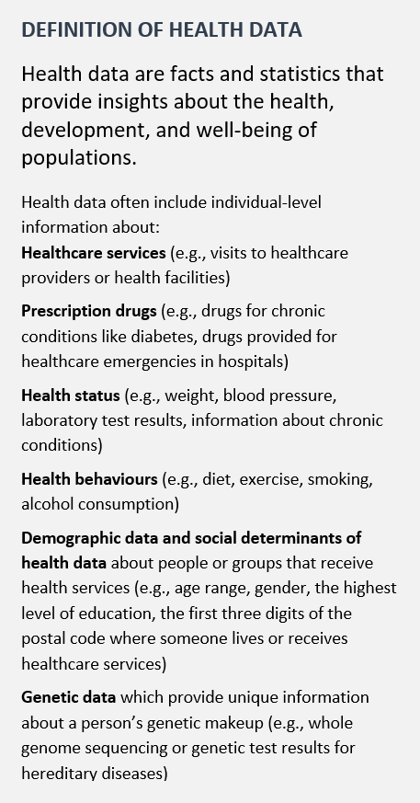
2.2 How are health data used?
Health data are already being used by people and organizations working directly in health services and healthcare delivery. For example, health data are used by:
- patients to understand their treatment options
- healthcare providers and academic researchers to improve their understanding of a specific medical condition
- public and private payers to inform decisions about access and reimbursement of health services
- policy makers to inform health policy
- health technology companies to inform research and development

Multiple reports and studies describe public benefits that could be achieved if we increase health data use, sharing, and re-use, and emphasize several points:
- the importance of privacy and data security
- implications for people and society when health data are underutilized
- the importance of including patients and members of the public in decisions about who has access to health data, and
- the need to increase equity in health data collection and use.

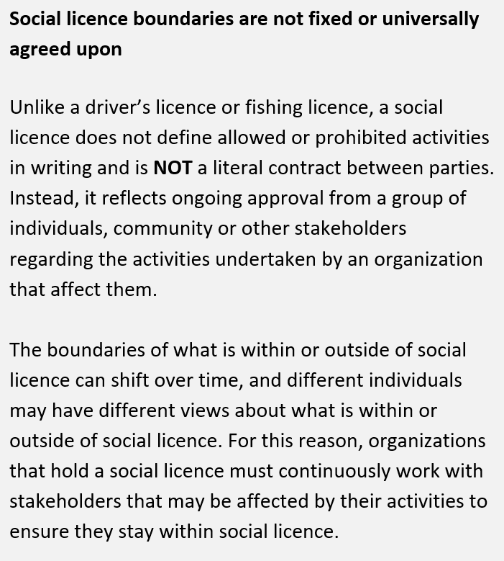
2.3 What is health data social licence?
A social licence to operate, or “social licence” for short, is granted to organizations by communities and stakeholders. This informal agreement is a kind of permission for organizations to perform certain kinds of work. It is possible for an activity to be legally allowed, but outside of social licence.

Increasingly, the term social licence is being used to describe which data-related activities have the support of members of the public, and under what conditions. To say that a use or user of health data is within “health data social licence” means that it is one of the uses or users that, at a minimum, is publicly acceptable, and ideally, has active public support.

3.0 Essential requirements for health data social licence

3.1 Our process for identifying essential requirements
Our first task was to have participants co-develop a list of essential requirements that a health data use or user would need to fulfill to be within social licence. Each participant worked individually, then participated in two sets of group discussions. Group discussions were facilitated by HDRN Canada and GRIIS project team members and conducted in the first language of the participants.
After hours of discussion and weeks of reflection there was no coalescence of views on essential requirements for health data social licence. Instead, based on participants’ input, the list of 40 requirements that was initially presented to participants was expanded to include 85 requirements in seven categories. In several cases, the differences between requirements were small, but seen as meaningful by participants.

3.2 Requirements for health data social licence, by category
To help participants think about requirements for health data social licence, we presented potential requirements in seven categories (see Table 1). Through the process, participants made many additions to the requirements, and some changes to the category names. Every one of 85 requirements identified by the end of the process was perceived to be essential by at least one participant. This highlights the diversity of participants’ views and confirms that each of the seven categories was perceived to be important.
Table 1: Categories of requirements for health data social licence
Requirement Category  (in alphabetical order) | Number of unique requirements in category at the beginning of the process | Number of unique requirements in category at the end of the process
A: Benefits | 5 | 9
B: Commercial Organizations | 6 | 11
C: Equity and Fairness | 5 | 5
D: Governance and Oversight | 8 | 18
E: Personal Control and Involvement | 6 | 13
F: Privacy and Security | 7 | 21
G: Transparency, Communications, and Data Literacy | 3 | 8
TOTAL | 40 | 85

3.3 Examples of requirements that were essential for many participants
The following requirements for health data social licence are examples of ones that many participants felt were essential. Underneath each requirement, we have included text in participants’ own words to show how participants articulated the requirement.
There is transparent and plain language, including language that is understandable by the general public (e.g., 8th grade reading level), about who has access to what data and for what purposes throughout the entire data lifecycle (from data collection to dissemination of findings). (8 of 20 participants identified this requirement as being essential).
“…It is important that the purpose of data collection and storing is clear, well communicated and known to all participants, if requested.”
“…the language should be a language everyone can understand – no ACRONYMS. This way all the population could understand and respond.”
People (and caregivers they authorize) can easily access health data that have been compiled about them in a usable format (e.g., one that can be read by a computer or electronic device) and in a timely manner so that they can make informed decisions about their health and health care. (8 of 20 participants identified this requirement as being essential).
“That the individual’s information is available to patients or their caregivers, preferably in the official language of their choice, or a reasonable accommodation thereof. Patients need improved access to their own information, in order to facilitate consent and healthcare decisions.”
“Ensure the individual has access to their own data. This includes offering computers and assistance, for example, for people who do not have them, but also ensuring that the platform where the data is hosted is accessible (language, visual impairments, etc.)”
Health data are held by organizations that are seen as trustworthy by the people and organizations that contribute data to them. (8 of 20 participants identified this requirement as being essential).
“Accountability - To build trust with the populations who would give up health data. The entities who collect and use health data should be held accountable for how these data are used.”

3.4 Examples of minority views on essential requirements
The inclusive design approach that we used increased the diversity of views captured and allowed us to identify views and requirements that were not present, or emphasized as strongly, in previous studies and reports. These minority views are important because people who hold minority views are often not well served by the status quo. In addition, they may hold knowledge that is essential to design processes, policies and products that work for the entire population, not just the majority. Examples of these less commonly identified requirements for health data social licence are provided below, along with related participant quotes.
Health data controls, safeguards, and regulations are proportionate and not so burdensome that they prevent benefits from being obtained from health data. (3 of 20 participants identified this requirement as being essential).
“The problems of groups that have suffered discrimination will not be solved by making it more difficult to use their data [if there are too many controls]. Their well-being could even be harmed.”
“We need to liberate this data for academics and government but also private sector especially when it comes to deidentified information.”
Organizations involved in data collection, processing, use, or re-use are respectful, polite, and welcoming when contacted by patients and members of the public. (1 of 20 participants identified this requirement as being essential).
“Respectful, polite and welcoming... will have ALL the [population] comfortable and at ease. It’s scary enough meeting new people and discussing lived experiences, make the surroundings warm, inviting”
When data are collected at the point of healthcare service delivery, communications address and mitigate the risk that patients (who are often in a vulnerable state) feel pressured to provide consent or agree to data access. (2 of 20 participants identified this requirement as being essential).
“Individuals seeking health care often find themselves in a physically or emotionally vulnerable situation. Trust and confidentiality is key to be able to expose that vulnerability and comply with care.”
[Patients are] “already feeling vulnerable when being treated for care and won’t say no when asked for consent. Acknowledging this vulnerability is important, especially for those who aren’t well educated.”
Unless there is expressed consent for data sharing outside of Canada, health data are stored in Canadian jurisdictions and stay within Canadian law. (2 of 20 participants identified this requirement as being essential).
“To build trust in the safety of our health data because the control of health data for those living in Canada is subject to our laws and regulations and not outside our legal control.”
A word cloud (Figure 2) was prepared to visualize minority views that were only expressed once or twice in the process. Comparing it to the word cloud on the title page illustrates how minority views were different than the overall and majority views that were expressed.
Figure 2: Word cloud presentation of ideas that were expressed by one or two participants
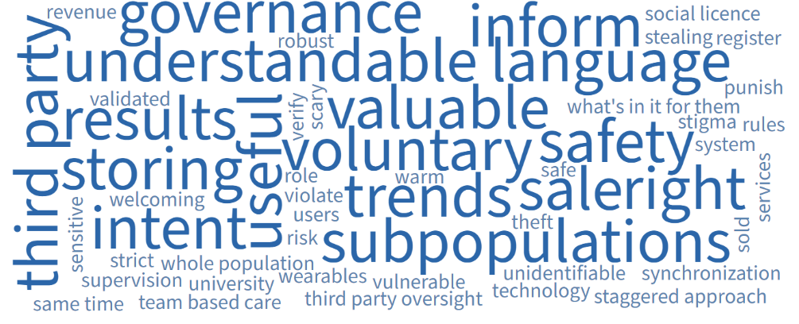

3.5 Examples of requirements that participants disagreed about
In some cases, one or more participants were opposed to requirements that other participants perceived to be essential. There was active disagreement on the requirements listed below and the related participant quotes help to illustrate the reasons for the disagreement.
People (and caregivers that they authorize) can easily access a usable copy of health data that has been compiled about them in a usable format (e.g., one that can be read by a computer or electronic device) in a timely manner so that they can make informed decisions about their health and health care.
[STATEMENT INDICATING AGREEMENT] “Healthcare team members have a fiduciary duty to patients. To instill trust, open and transparency of all derived health data from the patient is required to be provided to patients in machine readable format.”
[STATEMENT INDICATING AGREEMENT] “As responsible adults, patients should be entitled to all information about themselves. From laboratory reports to scan images (not just reports) and file notes. Above all, the same access as other care partners.”
[STATEMENT INDICATING DISAGREEMENT] “The security issue of individuals being able to access their health data is far too high and can jeopardize the privacy of individuals.”
Only data that have been truly anonymized (e.g., data that exclude names and other identifying information about individuals and communities) can be shared.
[STATEMENT INDICATING AGREEMENT] “[anonymization is] the only way for patients to be sure that their name cannot be linked to their personal data.”
[STATEMENT INDICATING DISAGREEMENT] “In cases where authorized individuals require identifying information in order to provide, or plan, healthcare services or in order to link datasets collected by different organizations, identifying information may be provided on a very restricted basis.”
Opt-in consent is obtained before health data are collected, used, shared, or re-used (i.e., people agree in writing to the use(s)/user(s) of their data).
[STATEMENT INDICATING AGREEMENT] “No sharing of this data without the consent of the person concerned”
[STATEMENT INDICATING DISAGREEMENT] “Regulation must not interfere with the use of health data for purposes that will benefit society. Too much protection, for example a regime that requires consent for each project (opt-in), can make research much more complicated if not impossible. It's a minority of people who will not want their data to be used; they must be given the opportunity to refuse without creating a system that causes barriers to research.”

4.0 Health data uses and users that are within and outside of social licence

4.1 Our process for identifying examples within and outside of social licence
Once the list of requirements had been updated to include participant views, the next task was to discuss specific examples of health data uses/users to determine whether those examples were within or outside of health data social licence from the perspective of participants. We increased our chances for agreement on this task because we didn’t present any examples of health data uses/users that participants had already expressed irreconcilable views about.

4.2 Examples that are WITHIN social licence
All participants agreed on three examples of health data uses/users that are within social licence:
- It is WITHIN social licence for health data to be used by healthcare practitioners to directly improve the healthcare decisions and services provided to a patient.
- It is WITHIN social licence for health data to be used by governments, healthcare facilities, or health system administrators to understand and improve health care and the healthcare system.
- It is WITHIN social licence for health data to be used by university-based researchers to understand the drivers of disease and wellbeing.

4.3 Examples that are NOT WITHIN of social licence
All participants also agreed on two examples of health data uses/users that are not within social licence regardless of the requirements, safeguards, conditions, or protections that may be in place:
- It is NOT WITHIN social licence for someone or some organization to sell (or re-sell) someone else’s identified health data.
- It is NOT WITHIN social licence for health data to be used for a purpose that has no patient, public, or societal benefit.

4.4 Examples that COULD BE WITHIN social licence
The participants did not come to consensus on any examples of health data uses/users that COULD BE WITHIN social licence with additional requirements, safeguards, conditions and protective measures in place.
The participants discussed, but did not agree, that it COULD BE WITHIN social licence for health data to be used by companies. Some participants felt that it is essential for companies to be able to use data from publicly-funded health services in order for the full range of benefits from health data to be realized. They suggested conditions such as: health data are not used for marketing purposes; and/or individuals who contribute their health data are not exploited by these companies. Other participants felt that some companies were not trustworthy and that the risk of breeches of trust or privacy by companies was unacceptable because harms to patients could not be undone if data were misused or got into the hands of malicious people. They also stated that the potential for harm to patients is greater when commercial interests are involved because, inherently, companies are primarily in business to make profits, not to serve the public.
Many participants agreed that it COULD BE WITHIN social licence for data about systemically marginalized populations to be used by researchers with added conditions and protections such as: Indigenous data sovereignty and the right to Indigenous self-determination are acknowledged and respected; health data are not used in ways that create stigma or discriminate against groups; populations have control over how their data are collected, used, shared, or re-used; people who contribute their health data are not exploited by any organization or individual; and/or health data are only collected used, shared, or re-used for purposes that the intended beneficiaries support. However, because there was skepticism and disagreement about whether the safeguards and conditions could be operationalized, there was not consensus about how or by whom data about systemically marginalized populations could be used.

5.0 Limitations, unanswered questions, and future work
The facilitated process and dialogue between participants generated many unanswered questions, particularly about the practical meaning of certain words or phrases related to health data social licence. Examples include:
- What constitutes a “legitimate” use of health data?
- What do we mean by a “sale of health data?”
- How quickly must patients’ access to their own data occur for it to happen “in a timely manner?”
- What does it mean for an organization to be “accountable”?
- What constitutes “exploitation” of an individual who contributes data?
Future work will need to clarify these and other terms for requirements to be put into practice.
The ideas in this report were generated based on hours of individual thinking and dialogue among experienced public and patient advisors. We recognize that, as a group, the participants are more likely to have knowledge of the benefits, risks, and opportunities associated with health data than many members of the public. It is possible that the examples of uses and users that our participants saw as being within social licence would be perceived as being outside of social licence by other people. It is also possible that there are uses and users of health data that are within social licence that were not identified in our process.
Our participants included one person who is First Nations and other non-Indigenous people who emphasized the importance of Indigenous rights, but the process did not focus specifically on the views of Indigenous Peoples. Separate Indigenous-led work would be required to identify the perspectives and concerns of First Nations, Inuit, and Métis Peoples related to health data social licence.
On a related note, though we brought together the most diverse group of participants possible from the people that applied, and participants discussed the needs and interests of historically marginalized populations, additional work would need to be undertaken to understand health data social licence from the perspective of people and groups that are different from mainstream society because of their race, abilities, language, gender, and other characteristics.
Additionally, while we observed some differences in the views between the English and French participant groups, more work would need to be performed to determine whether these differences were generalizable and/or associated with cultural or linguistic factors.
For the above reasons, this report should not be seen as a final answer on the topic of health data social licence. Rather, we encourage its use as an input for future or ongoing public involvement and engagement initiatives that include members of the public who do not have prior experience related to health data.

6.0 Acknowledgements
We thank the following people for their contributions:
- Public and patient advisors who served as peer reviewers: Collette Bérubé, Louise Belzile, Louise Binder, Cris Carter, André Gaudreau, Maggie Keresteci, Rhonda Massad, Annette McKinnon, Annie Poirier, Luc Ricard, Maureen Smith, Leah Stephenson, and Cindy Ying Yin Yip
- Members of the Health Data Research Network Canada Public Engagement Working Group (which also includes co-authors Julia Burt, Annabelle Cumyn, Roxanne Dault, and P. Alison Paprica) who co-developed the initial list of requirements for health data social licence and provided advice on the process: Jean-François Ethier, Frank Gavin, Kimberlyn McGrail, Jenine Paul, and Catherine Street
- Kwame McKenzie, CEO of the Wellesley institute, who provided advice on the initial list of requirements for health data social licence

7.0 List of appendices
- Principles and approach (82.7KB read-only MS Word)​
- Process (85.5KB read-only MS Word)​
- Table of requirements for health data social licence (98.3KB read-only MS Word)​
- Examples of requirements in participants’ own words (68.7KB read-only MS Word)​
- Word clouds (382KB read-only MS Word)​
- Peer reviewer feedback (71.4KB read-only MS Word)

