HDRN Canada
Scientific Director & CEO’s Report

September 9, 2026

Table of Contents
Section 1: Organizational Performance Indicators Dashboard 3
Section 2: Key Achievements on Strategic Commitments 4
Goal 1: Develop and Improve Services and Supports for Data Access 4
Goal 2: Diversify and Harmonize Data, and Support Innovative and Privacy-Sensitive Data Use 7
Goal 3: Establish and Strengthen Partnerships and Provide Leadership for Evolving Data Practices 8
Goal 4: Strengthen Data Use to Improve Equity, and Support Indigenous-led Data Sovereignty 11
Goal 5: Ensure Purposeful and Ongoing Public and Community Involvement 13
Success Factor: Cohesive Network with Effective and Sustainable Operations 15
Success Factor: Supportive and Engaged Legislative and Policy Ecosystem and Community of Data Users 16

Abbreviations
CAN-ASK: Pan-Canadian Data Analytic Service for Knowledge Users
CanPath: Canadian Partnership for Tomorrow’s Health: A large, longitudinal cohort
CDM: Common Data Model
CFI: Canada Foundation for Innovation
CIHI: Canadian Institute for Health Information
CIHR: Canadian Institutes of Health Research
DAI: Data Asset Inventory: One of the resources developed by HDRN Canada
DASH: Data Access Support Hub: A Team within HDRN Canada
HDT: Harmonized Data and Tools: A Team within HDRN Canada
IDEA: Inclusivity, Diversity, Equity, and Accessibility
IDT: Indigenous Data Team
OMOP: Observational Medical Outcomes Partnership: A widely used common data model that HDRN Canada is implementing
PAC: Public Advisory Council: An advisory body supported by HDRN Canada
PE: Public Engagement: A Working Group within HDRN Canada
PHAC: Public Health Agency of Canada
PTTP: Pragmatic Trials Training Program: A program hosted by HDRN Canada
TRE: Trusted Research Environment: Terminology for secure spaces where data analysis happens

Section 1: Organizational Performance Indicators Dashboard
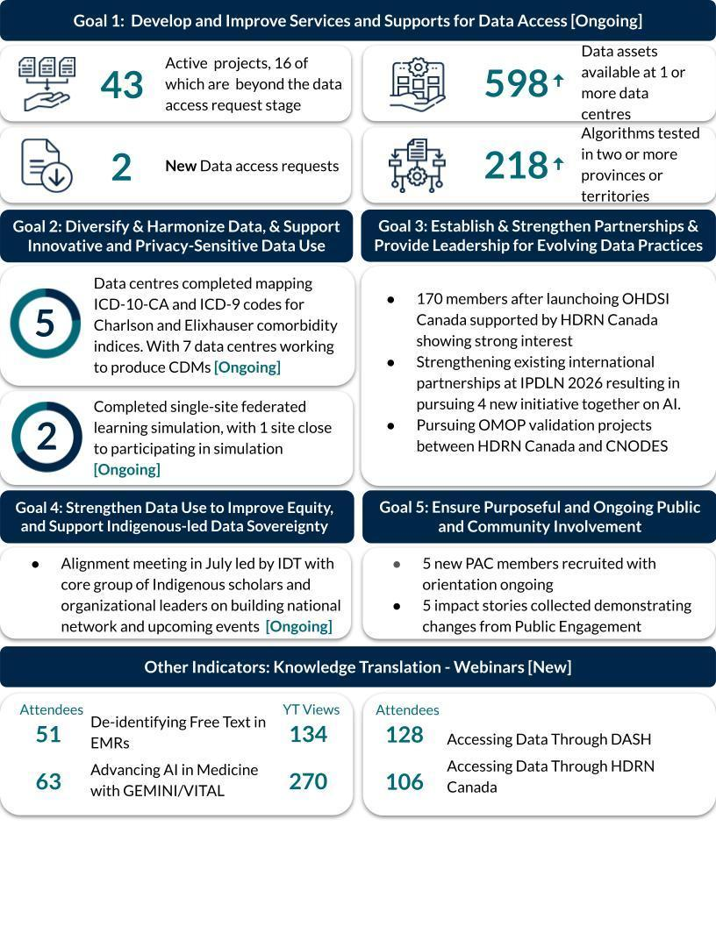
Note: Indicators are updated quarterly. Ongoing or new initiatives are denoted in square brackets.

Section 2: Key Achievements on Strategic Commitments

Goal 1: Develop and Improve Services and Supports for Data Access

Integrated Data Services Team
There has been a significant effort to integrate and improve services through DASH and CAN-ASK. These are now integrated as Data Services.
Service Development & Implementation
- Implementation of HDRN Canada’s integrated data services model by building on our co-created Integrated Services Blueprint to define workflows, service processes, staffing and governance structures, and client pathways. This work is establishing a more coordinated and consistent approach to supporting clients and delivering multi-regional data services across the network.
- Implemented a more integrated staffing and governance model that brings together service delivery roles such as case managers, data scientists, analysts and data access coordinators, alongside dedicated service development functions. A new Lead - HDRN Canada Data Services Development started on August 31st. Hiring for the Lead - HDRN Canada Data Services Delivery is underway.
- Introduced a stronger case management approach for multi-regional projects, including co-case managers (one central and one site level) to coordinate the overall project. We are working with participating site representatives to provide clients with a clearer point of coordination, reduce fragmentation across sites, and improve consistency in project delivery.
- Developed a service package framework to improve costing transparency and service planning providing a clear distinction between HDRN Canada grant-supported activities and client-funded or cost-recovered services. This clarification will help clients better understand what is included in project estimates and the full suite of services that are available through HDRN Canada.

Client Access, Engagement & Promotion
- The webpages for Data Services are being updated to reflect the new integrated approach. As part of this, we have already transitioned to a single entry point via HDRN.ca to support all client groups. We developed tailored client-facing information, including services options, for publicly funded researchers, government, not-for-profit organizations, and industry.
- Launched our rebranded HDRN Canada Data Services through a public webinar on July 30. Canadian-based and international participants included publicly funded researchers (37%), government and not-for-profit knowledge users (27%), and industry (6%). In the 10 days following the webinar, HDRN Canada received 10 new queries and three new intake requests, demonstrating clear interest in our redesigned and expanded service offerings.
- Worked with colleagues at CIHR to increase visibility of HDRN Canada Data Services in research calls. HDRN Canada Data Services will be included in future ResearchNet Project Grant materials and on broader researcher resource pages, creating opportunities to reach researchers earlier and increase uptake of multi-regional data services. HDRN Canada Data Services was advertised for the Analysis of Human Development, Child and Youth Health Data funding opportunity, and will be featured on additional upcoming calls.
- Strengthened HDRN Canada’s national and international visibility and knowledge sharing through presentations at Canadian Association for Health Services and Policy Research (CAHSPR) and International Population Data Linkage Network (IPDLN) conferences. We showcased key initiatives including the User Experience Framework, jurisdictional data access requirements, and distributed analysis.
Network Implementation & Distributed Analysis
- Expanded the reach of distributed analysis across Canada, with all but one province now participating.
- Strengthened consistency in the delivery of distributed analysis projects through the development and dissemination of a briefing note for data centres. This provides practical guidance, including ethics language and other resources that can be used for local conversations around data governance.
- Continue to search for opportunities to reduce complexity and improve coordination for multi-jurisdictional research data access. Recent efforts have focused on individual site consultations, now completed with AB, SK, MB, ON, NB, NL, NS and PE.
Performance Measurement & Continuous Improvement
- The team is refining a small number of “North Star” indicators for Data Services to measure progress in three core areas of interest to CIHR: increasing uptake and use; improving client experience; and demonstrating impact. These will be shared with our member data centres for input and buy-in before being finalized.
- We are ready to start recruiting a Research Panel. The first two use cases that will be discussed with that panel are 1) reviewing and identifying opportunities to improve the HDRN Canada Data Services website and webinar materials; and 2) reviewing the Data Assets Inventory to improve data discovery. We are finalizing recruitment materials, including a recruitment pitch, flyers and an expression-of-interest web form. These will be shared with senior leadership and then used to launch recruitment.

Management of Data Services (formerly DASH & CAN-ASK) Projects:
- Researcher Clients (formerly DASH): There are 18 completed projects to date. Currently, there are 43 active projects, with 16 of those at or beyond the data access request stage.
- Public and Private Sector Clients: There are five completed projects to date (clients: Canada’s Drug Agency, Immigration Citizenship and Refugees Canada, and one private sector). Currently, there are two active projects (clients: Canada’s Drug Agency and University of Toronto Innovation Lab). There are an additional six projects currently in the intake and scoping phase.
- ISQ, our partner for researcher-led projects, is not enabled to serve public and private sector clients. Santé Québec’s Research Access Centre (CAR) has a mandate to provide support services for accessing provincial health data for industry, researchers outside Quebec, and researchers in Quebec who are not affiliated with the health system. We are working with CAR to create a pathway for including Quebec in public and private sector client projects.

Goal 2: Diversify and Harmonize Data, and Support Innovative and Privacy-Sensitive Data Use

Preliminary results support the feasibility of using federated learning to develop MASK, a machine learning model for de-identifying free-text
- Ontario and Manitoba have successfully completed single-site federated learning simulations, with results demonstrating comparable and consistent model performance across the two sites. These findings support progressing to multi-site federated learning to develop a robust global MASK model.
- Alberta is nearing completion of local model development and is preparing to participate in the federated learning simulation, pending completion of its privacy review and required approvals.
- Preliminary results were presented as a rapid talk at IPDLN 2026.

Strengthening the foundation for OMOP implementation and research across HDRN Canada sites
- Five sites (ON, BC, NS, NB, and PEI) completed mapping ICD-10-CA and ICD-9 diagnostic codes for the Charlson and Elixhauser comorbidity indices. Validation of the Canadian Charlson mappings against an established OMOP algorithm showed strong alignment in the underlying clinical concepts. This work is building reusable approaches and expertise for Canadian vocabulary mapping, supporting OMOP implementation, and future translation and validation of established Canadian clinical phenotypes.
- An abstract on the mapping and validation work was presented as a rapid talk at IPDLN 2026 and has been submitted for poster presentation at the 2026 Global OHDSI Symposium.
- In addition, the team is developing two use cases to guide future data mapping and transformation, support the onboarding of additional sites, and testing the feasibility of using OMOP for more complex analyses. One use case will also enable comparison of OMOP with the CNODES Common Data Model, which is currently available at some participating sites.

Goal 3: Establish and Strengthen Partnerships and Provide Leadership for Evolving Data Practices

International Partnerships
HDRN Canada hosted an AI-focused meeting of our international partners at IPDLN 2026 (HDRN Canada, Health Data Research UK, Administrative Data Research UK and Data Connect Australia (formerly PHRN Australia)). In preparation, each organization was invited to prepare an AI briefing describing its current AI activities, strategic priorities, challenges and opportunities for collaboration. HDRN Canada surveyed its members as part of this process and produced an HDRN Canada AI Brief and then the synthesized International Partners AI Brief.
The meeting resulted in agreement to pursue the following initiatives together:
- Definition and Framework for Understanding AI in Population Data Research HDRN Canada will lead a consultative process to develop this.
- Standardized AI Risk Assessment Framework for Sensitive Data in TREs: HDR UK will coordinate collaborative development of AI Risk Assessment Frameworks with a focus on machine learning and emerging AI models.
- Social License for Using AI in Population Data Linkage: Data Connect Australia will lead planning for a meeting in October to continue work in this area
- Training and Capacity Building for Using AI in Population Data Analysis: ADR UK will lead development of options for improving base level of understanding across our organizations through training, events, and signposting.
Launching and Building the Canadian OMOP Common Data Model Community
- HDRN Canada launched Observational Health Data Sciences and Informatics (OHDSI) Canada, the Canadian chapter of the global collaborative supporting the use and evolution of the OMOP Common Data Model. This is generating strong interest; we have 170 members and are still growing. HDRN Canada is supporting the chapter’s development by coordinating regular community meetings, including the first monthly meeting in June (38 attendees) and the vocabulary mapping subgroup meeting in July (43 attendees).
- Building on the success of the inaugural 2025 OMOP Common Data Model Engagement Event, HDRN Canada is leading planning for the second in-person event, taking place November 17-18 in Toronto. This will bring together and further strengthen the growing Canadian community implementing and using OMOP.

Health Data Research Alliance
The HDR Alliance met on May 20 and discussed what it collectively can contribute to the development of Canada’s AI-ready health data infrastructure.
- HDR Alliance members will participate in the international partners work on AI, enhancing the expertise engaged and enabling broad adoption of the guidance
- We will create a document articulating the HDR Alliance’s collective expertise, capabilities and services related to AI-ready health data infrastructure. We will prepare learning materials to increase awareness and understanding among the Canadian research community about synthetic data, including its uses and its challenges. Learning materials will include a glossary of terms, an annotated bibliography, FAQs, and webinar(s) based on these products.
- The Working with the Federated Data Forum in June focused on the HDRN Canada-led initiative to establish an OHDSI chapter in Canada. HDR Alliance members are now joining the chapter.

Pan-Canadian Partnerships
We continue to meet regularly with pan-Canadian partners to identify and pursue partnership initiatives including GEMINI/VITAL, CNODES, CLSA and IRCC.
- Representatives of VITAL are meeting with HDRN Canada leads in MB and SK to consider linkage to our sites as part of their pan-Canadian expansion
- ISQ (Quebec) signed a data sharing agreement with CLSA; NLHS and MCHP are close to signing as well
- IRCC is attending HDRN Canada | IRCC Steering Committee meeting on August 24 to discuss sharing the Immigrant Medical Exam as an extension to the current Provincial Data Linkage Program
- HDRN Canada and CNODES are pursuing OMOP validation project together

Develop national and international public engagement collaborations
- Continued quarterly joint meetings with Canadian Health Information Management Association (CHIMA) to share public engagement practices, approaches and updates.
- Maintained regular attendance and active participation in SPOR Patient Engagement Community of Practice (SPENCoP) through the Public Engagement Operational Lead.
- Piloted the first joint quarterly meeting between IDEA and Public Engagement teams to strengthen collaboration, increase synergy and advance shared objectives.
- The Public Engagement Team continued to play an active role in cross-cutting HDRN Canada initiatives, contributing to the Private Sector Safeguards and Engagement CAN-ASK tactical teams, as well as IDEA Strategy Subgroup focused on trust and reciprocity in communities.
- Welcomed and oriented three new team members from NL SUPPORT, SIDR (PEI) and HRDP-SK.

Goal 4: Strengthen Data Use to Improve Equity, and Support Indigenous-led Data Sovereignty

We are supporting the development of a national Indigenous data sovereignty network:
The Indigenous Data Team (IDT) Lead is engaging a core group of Indigenous scholars and organizational leaders who will lead the development of a national network for data sovereignty and governance. This core group will include scholars and leaders from several organizations, including CIHR’s Institute of Indigenous Peoples' Health, Schkaabe Makwa, the First Nations Information Governance Centre, the First Nations Health and Social Secretariat of Manitoba, heritagelab, McMaster Indigenous Research Institute, University of Saskatchewan and University of Toronto.
This core group met in July to discuss the approach to building a national network, upcoming events, and supplementary funding opportunities for IDT initiatives and events. Conversations highlighted the need to honour the individual identities and mandates that each organization has worked hard to establish. This core group will gather again in fall/winter 2026 to discuss shared goals and roles in advancing these goals.
Our goal for a large Indigenous data governance and sovereignty working session has shifted to spring/summer 2027, in advance of the GIDA (Global Indigenous Data Alliance) meeting in Canada in September 2027.
We are currently in the hiring process for two staff who will support the role of the Indigenous Data Team Lead and the development of a national network and IDT strategy.

We are supporting collaborations with Indigenous data sovereignty networks globally:
We continue to collaborate with the Global Indigenous Data Alliance. Core leads of the national Indigenous data governance and sovereignty network are organizing the next international meeting in Vancouver in September 2027.

We are implementing the IDEA strategies that are part of our Strategic Plan:
IDEA Strategy 1: Learning/Unlearning
- Completed 18 months of IDEA Community of Practice Unlearning sessions. The first six months of the curriculum were released on our website and four mini-module videos were co-created with members of the Community of Practice and released on HDRN Canada’s YouTube channel.
- The Unlearning sessions will wrap up in the fall and work is underway to move back through the modules and share successes and challenges moving IDEA work forward.
- Core IDEA competencies are being curated and mapped by the IDEA Team and IDEA Community of Practice.
IDEA Strategy 2: Facilitating IDEA in Data Research
- The enhanced metadata work is moving forward.
IDEA Strategy 3: Cultivating Trust and Reciprocity in Community Partnerships
- An infographic was created to guide groups starting new projects around the need for public engagement. An annotated companion document will guide readers through the processes and offer further resources to help with decision-making.
- A public-benefit screening tool is being developed to guide stewardship of data access requests coming through Data Services, with particular focus on private sector requests.
IDEA Strategy 4: Providing Guidance and Leadership to Advocate for IDEA
- The evolved Five Safes Framework was presented at IPDLN 2026 with excellent support.
- IDEA Team members are involved in developing the HDRN Canada Data Services platform and related website content.
- The IDEA Team is creating benchmarks to assess HDRN Canada’s current progress toward embedding IDEA across the network and to guide initiatives and strengthen our capacity in IDEA. The benchmarks will be completed in Q2 2026 and distributed in the fall.

The Big IDEAs About Health Data Speaker Series continues to draw attention:
- Season four of the Big IDEAs About Health Data Speaker Series is scheduled. The new season includes five webinars scheduled from September 2026 to May 2027.

Abstracts & Publications:
- Manuscript Co-creating an Inclusion, Diversity, Equity, and Accessibility (IDEA) Strategy in a Pan-Canadian Health Data Research Network was published in the International Journal of Population Data Science.

Goal 5: Ensure Purposeful and Ongoing Public and Community Involvement

Maintain and strengthen Public Advisory Council operations
- Invited 18 of 125 Public Advisory Council (PAC) applicants to interviews, resulting in the recruitment of five new PAC members. Orientation materials have been drafted, and member orientation is ongoing.
- Conducted three exit interviews with outgoing PAC members, with positive and constructive feedback received.
- Conducted the PAC end-of-year survey, with positive results. Findings will be shared in the upcoming Public Engagement Team/PAC report.
- Held a PAC meeting in June prior to the summer break. The meeting included an “Into the Future” stress-testing exercise to explore and assess PAC priorities and their relevance to future needs.
- Materials for October’s Health Literacy Month are drafted, with three PAC members actively involved in the working group. One PAC member chaired meetings for this purpose.

Explore AI tools in public engagement and/or social license of AI use in health care
- Planned an October 2026 meeting with HDR UK and Data Connect Australia to discuss social licence considerations related to the use of AI in health care.
- Public Engagement and IDEA Teams working together to identify initial project ideas

Demonstrate and report changes resulting from public input
To support continuous learning and accountability, the Public Engagement Team developed and implemented a new evaluation framework, including a structured process for collecting impact narratives from SPOR Support Units and data sites. Five stories were collected from three sites. These stories demonstrated that HDRN Canada's public engagement resources (including governance models, orientation materials, facilitation approaches, and plain-language tools) are being adapted and adopted across the country. Partners reported using HDRN Canada's resources to establish new Public Advisory Councils, strengthen governance, develop social licence initiatives, and improve onboarding for patient and public partners, reinforcing HDRN Canada's role as a national leader in building meaningful and sustainable public engagement capacity.
These narrative reports indicated the following:
- HDRN Canada's PAC governance is being model replicated. NL SUPPORT (Newfoundland and Labrador's SPOR SUPPORT Unit) used HDRN's PAC Chair role description, Terms of Reference, and honorarium policy to transition their own Patient and Public Advisory Council from a rotating chair model to a year-long chair model in 2025 - a change their own PPAC members had been asking for to gain more agency over council activities. Their first year-long Chair was elected at the end of 2025.
- HRDP-Saskatchewan's PAC was established using HDRN resources as its foundation, drew on HDRN Canada’s PAC orientation materials, sample Terms of Reference, onboarding documentation, and the PAC Annual Report to develop their own governance structures, reducing duplication and aligning with national public engagement standards from the outset. A cross-jurisdictional leadership link (the HRDP-SK PAC Chair also holding a role in the HDRN Canada PAC) further accelerated the group's early development and helped establish a culture of respectful dialogue from day one.
- HDRN's social licence work shaped how partner organizations design their own engagement. The Maritime SPOR SUPPORT Unit built a regional social license project based on HDRN Canada's national foundations, using HDRN Canada's Social Licence Report, the Public and Patient Engagement Evaluation Tool (PPEET) results, and facilitation tools (including the Fist to Five voting method) to deliberately broaden their reach beyond participants already familiar with health data research. French-language sessions were added for francophone participation. The result: improved participant understanding of health data, increased comfort with health data conversations, and meaningful public input that would not have been reached otherwise.
- HDRN's plain-language health data glossary, developed by PAC members, is being considered as an onboarding tool by partner organizations. HRDP-SK added the glossary to a recent PAC meeting agenda to explore whether it could support new member onboarding and be adapted to a Saskatchewan context, reflecting the resource's value beyond HDRN's own work.

Success Factor: Cohesive Network with Effective and Sustainable Operations

Improving cross-team collaboration and capacity-building
- Piloted the first joint quarterly meeting between IDEA and PE teams to strengthen collaboration, increase synergy, and advance shared objectives.
- The PE Coordination Team continued to play an active role in cross-cutting HDRN Canada initiatives, contributing to the Private Sector Safeguards and Engagement CAN-ASK (now Data Services) tactical teams, as well as IDEA Strategy Subgroup Three, focused on trust and reciprocity in communities.
- Created a Public Engagement Team Orientation Brief, which was used as part of the orientation for three new PET members.

Success Factor: Supportive and Engaged Legislative and Policy Ecosystem and Community of Data Users

Active HDRN Canada participation in Collaboratorium initiative
- HDRN Canada members actively participated in Collaboratorium working groups, shaping the roadmap for a national federated health data ecosystem. Built on sovereign compute infrastructure, this effort will drive secure, responsible and scalable health data use across Canada.

