HDRN Canada
Scientific Director and CEO’s Report
May 13, 2026

Table of Contents
Section 1: Organizational Performance Indicators Dashboard 3
Section 2: Key Achievements on Strategic Commitments 4
Goal 1: Develop & Improve Services & Supports for Data Access 4
Goal 2: Diversify & Harmonize Data, and Support Innovative and Privacy-Sensitive Data Use 5
Goal 3: Establish & Strengthen Partnerships & Provide Leadership for Evolving Data Practices 6
Goal 4: Strengthen Data Use to Improve Equity, & Support Indigenous-led Data Sovereignty 9
Goal 5: Ensure Purposeful & Ongoing Public & Community Involvement 12
Success Factor: Cohesive Network with Effective & Sustainable Operations 14
Success Factor: Supportive & Engaged Legislative & Policy Ecosystem & Data Users 14
Summary of Board Follow-up Action Items 15

Abbreviations
ARCHIMEDES: Advanced Research Collaboration for Health Integration, Medical Exploration, & Data Synthesis
CAN-ASK: Pan-Canadian Data Analytic Service for Knowledge Users
CanPath: Canadian Partnership for Tomorrow’s Health: A large, longitudinal cohort
CanSPARK LTC: Canada Supporting Partnerships to Advance caRe and Knowledge in Long-Term Care
CDM: Common Data Model
CFI: Canada Foundation for Innovation
CIHI: Canadian Institute for Health Information
CIHR: Canadian Institutes of Health Research
CNDR: Canadian Neuromuscular Disease Registry
CORE: Canadian Centre for Recovery Excellence
DAI: Data Asset Inventory: One of the resources developed by HDRN Canada
DASH: Data Access Support Hub: A Team within HDRN Canada
HDT: Harmonized Data and Tools: An HDRN Canada Team
IDEA: Inclusivity, Diversity, Equity and Accessibility
IDT: Indigenous Data Team
OMOP: Observational Medical Outcomes Partnership: A common data model that HDRN Canada is implementing
PAC: Public Advisory Council: An advisory body supported by HDRN Canada
PE: Public Engagement: An HDRN Canada Team
PHAC: Public Health Agency of Canada
PTTP: Pragmatic Trials Training Program: A program hosted by HDRN Canada
TRE: Trusted Research Environment: Terminology for secure spaces where data analysis happens

Section 1: Organizational Performance Indicators Dashboard
Note: Indicators are updated quarterly. Ongoing or new initiatives are denoted in square brackets.
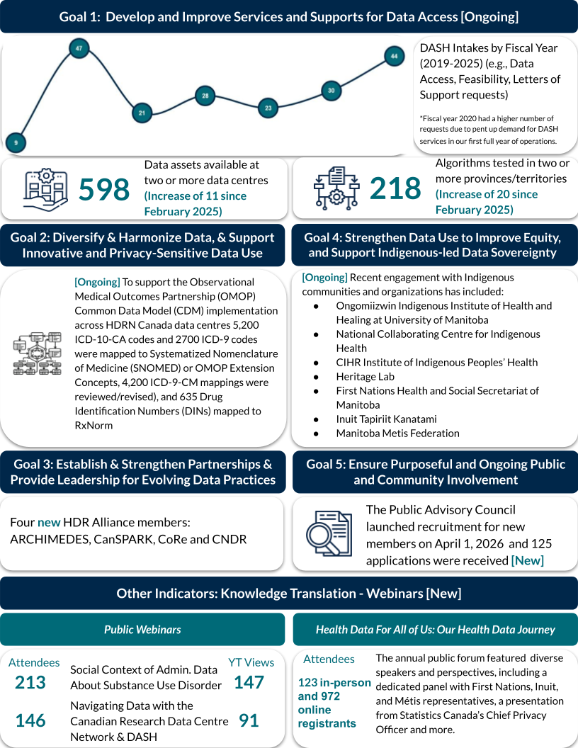

Section 2: Key Achievements on Strategic Commitments

Goal 1: Develop and Improve Services and Supports for Data Access

Integrated Services Team
- The Team is developing a new service design blueprint for integrating our DASH and CAN-ASK services. The new features include:
  - Increased promotion and relationship management: Single front door, expanded promotional channels, and more active client engagement
  - Enhanced integrated, network-wide service model: Integrated Network team, manage multi-regional projects rather than series of site-level projects, comprehensive service lifecycle
  - Structured,but customizable service packages: A base package plus additional modules tailored to client and project needs
  - Proactive project planning and management: Earlier structured project planning, strengthened case management, scientific support and proactive tracking and escalation
- “North Star” indicators are being developed for integrated services. These are a small number of indicators that will tell us whether we are making tangible progress in three core areas of interest to us as well as to CIHR: increasing impact and use, improving the client experience, and demonstrating impact.
- Consultations are being conducted with network members to provide detailed documentation on their data access processes and associated requirements. To date, consultations have been completed with Alberta, Manitoba, Saskatchewan, Ontario, New Brunswick, Newfoundland and Labrador, and Nova Scotia.
- Briefing materials, protocol language and other resources are in development to support the implementation of distributed analytics across the network.
- Development of the modernized user portal is ongoing, including the introduction of new DASHBoards designed to enhance the experience. The launch will happen soon!
- Increased promotional efforts include:
  - The list of completed projects through DASH (including resulting publications) is now available on the HDRN Canada website (Projects | HDRN Canada). The goal is to incorporate CAN-ASK projects to this list soon.
  - Member organizations were asked to promote HDRN Canada and DASH on their local websites. Most sites have done this now, with a few remaining to be done.
  - A Researcher Panel is being developed to improve the design of HDRN Canada services and provide input on all of our initiatives. A working group developing the panel’s design and planning has drafted the Terms of Reference and a broad framework for the panel’s composition.

Management of DASH Projects
- There are 15 completed projects to-date and three more are at completion (we are just waiting on the research team to close them from our queue). Currently, DASH has 28 active projects, with 15 of those at or beyond the data access request stage.
- One project is in active stages of completing a distributed analysis. There are nine other active projects considering distributed analysis.

Goal 2: Diversify and Harmonize Data, and Support Innovative and Privacy-Sensitive Data Use

Updated Data Availability Visualization in Progress
- The Harmonized Data and Tools (HDT) Team updated the data grid originally developed by the Public Engagement Team to provide a clear snapshot of data availability across member data centres. The grid now includes PEI and QC and expands on the original version to capture additional data types and information on update frequency.
- Additional work is underway to refine the data categories and develop a public-facing version for the website. This updated grid will improve transparency and support greater understanding of data availability across the sites.

Pan-Canadian Concept Dictionary Development Moving From Pilot Phase to Local Deployment and Testing
- The HDT Team is preparing to move beyond the pilot phase of the Pan-Canadian Concept Dictionary toward broad implementation. The Public Advisory Council is reviewing and refining plain-language descriptions and frequently asked questions for inclusion on a public-facing webpage.
- Work with SAIL (Secure Anonymised Information Linkage) Databank, which developed the prototype, is underway to set up the platform locally and migrate pilot concepts for continued testing and improvement of the tool before it is officially launched.

Privacy Review Completed Ahead of Federated Learning Deployment of MASK Machine-Learning De-Identification Tool
- A privacy audit was completed in Manitoba as part of preparing for the federated learning phase of the MASK model development. The assessment found no evidence that direct personal identifiers (e.g., health card numbers) are retained by the model during training. A limited risk was identified in certain situations; this information is being used to strengthen privacy protections before federated learning begins.

Goal 3: Establish and Strengthen Partnerships and Provide Leadership for Evolving Data Practices

International Collaborations
- HDRN Canada continued to strengthen its international leadership in public engagement and data governance through ongoing collaborations and meetings with partner organizations. Engagements with Population Health Research Network Australia (focused on social licence), Understanding Patient Data UK (focused on the European Health Data Space), and Health Data Research (HDR) UK (focused on AI in public engagement) supported cross-jurisdictional learning on emerging approaches to trust, engagement and responsible use of health data. These discussions position HDRN Canada within a global network of organizations advancing public engagement in data-intensive environments.
Patient Engagement-Related Partnerships in Canada
- HDRN Canada maintained and strengthened national partnerships through ongoing engagement with organizations including the Patient Advisors Network and VITALl/GEMINI. These relationships supported continued alignment across complementary initiatives in public engagement and health data infrastructure and contributed to broader system-level coordination as it relates to public engagement within Canada’s health data ecosystem.
- The Patient Engagement Operational Lead participated in and presented at the SPOR Patient Engagement Community of Practice, contributing to national-level knowledge exchange through ongoing bi-monthly meetings.

Launched a Network to Advance Adoption and Use of the Observational Medical Outcomes Partnership (OMOP) Common Data Model (CDM) in Canada
- HDRN Canada led the creation of a Canadian chapter of the Observational Health Data Sciences and Informatics (OHDSI) community, a multidisciplinary and global collaborative that supports the use and evolution of the OMOP CDM. The OHDSI Canada chapter has received official approval from the global OHDSI Steering Committee. Objectives and key results for 2026 have been defined, and two subgroups are being established to coordinate vocabulary mapping to OMOP standards and support multi-site evidence generation.
- HDRN Canada’s leadership enhances the visibility and credibility of HDRN Canada, both nationally and internationally. It also creates new opportunities for partnerships and large-scale multi-site research collaborations.

Pragmatic Trials Training Program (PTTP)
- A second conference has been put on by the PTTP which featured eight Trial Leader protocol presentations, 15 expert panelists and a live demonstration. There were over 100 registrants for the event which facilitated meaningful engagement and generated live feedback. This feedback will be incorporated into the trial protocols, leading to improved integration into routine care, greater sustainability beyond trial completion and enhanced patient impact.
- A dedicated learning series, Leaders in Indigenous Health Care, was put on by the PTTP which included four presenters and conversations with two Indigenous Knowledge Keepers, exploring topics such as the principles governing administrative data, Indigenous history, and the integration of Elders’ principles into research practices. This work is anticipated to enhance awareness and promote alignment with Indigenous principles of ownership, control, access and possession, including improved community engagement and refinement of data usage.
- A manuscript has been submitted for publication that details the PTTP’s key characteristics and anticipated impact. The manuscript documents the development of over 90 open access educational modules, more than 90,000 interactions with the program website, and the creation of over 20 protocols. Together, these outputs contribute to a structured framework that can inform and support future training initiatives.

The Health Data Research (HDR) Alliance
- A new webpage for the HDR Alliance was produced in March. Work is underway to promote the impact of the HDR Alliance and will be added to the webpage.
- Four new members have joined the HDR Alliance: Advanced Research Collaboration for Health Integration, Medical Exploration, and Data Synthesis (ARCHIMEDES), Canada Supporting Partnerships to Advance caRe and Knowledge in Long-Term Care (CanSPARK LTC), Canadian Centre for Recovery Excellence (CoRE), and the Canadian Neuromuscular Disease Registry (CNDR).
- HDR Alliance priorities for 2026 include:
  - Become a signatory to the Digital Operational Resilience Act (DORA) research assessment framework and continue impact reporting work
  - Produce a joint submission on Bill S-5 Connected Care for Canadians Act (completed and now on the Senate website)
  - Explore strategic partnership opportunities related to AI Sovereign Compute Infrastructure Program
  - Produce “explainer” papers/videos on: data as infrastructure; synthetic data; AI and data governance
- The Working with Federated Data Forum meetings have been very well attended in 2026. The most recent presentation in April was by Robert Platt (the HDR Alliance Chair) on Generative AI for Disease Modelling.

SPOR Canadian Data Platform Advisory Committee
- The Committee held its nineteenth meeting in March. Planning for DASH/CAN-ASK Integrated Services, the Algorithms Inventory and communications strategy were discussed.
- Dr. Kim McGrail will step down as Chair of the Committee and Michelle Leach, Scientific Director of the Yukon SPOR SUPPORT Unit (YSPOR), an HDRN Canada member, will be the new Chair starting June 12.

Collaboration with International Partners
- Plans are underway for a meeting of organizational leaders at the 2026 International Population Data Linkage Network (IPDLN) Conference. This meeting will include HDRN Canada, HDR UK, Administrative Data Research UK and PHRN Australia. We are conducting a survey of leaders of all of these organizations now to determine the focus of the meeting.

Goal 4: Strengthen Data Use to Improve Equity, and Support Indigenous-led Data Sovereignty

Supporting the Development of a National Indigenous Data Sovereignty Network:

Collaborations with Indigenous scholars, organizations, community
- We are strengthening our relationship with Shkaabe Makwa (at the Centre for Addiction and Mental Health) in Ontario. We are discussing ideas for engaging potential members of a national Indigenous data sovereignty network. Together, we are planning a follow-up national Indigenous data sovereignty and governance working session in Fall 2026. We hope to work together with Ongomiizwin Research to host the working session at the next Ongomiizwin Symposium, building on the relationships that Shkaabe Makwa, Ongomiizwin, and the Indigenous Data Team (IDT) have with Indigenous scholars, organizations and community.
- The IDT Lead is engaging with Indigenous scholars, organizational leaders, and community members in other spaces: HDRN Indigenous Data Practices Team, IDEA Team, Ongomiizwin Indigenous Institute of Health and Healing (at the University of Manitoba), National Collaborating Centre for Indigenous Health, CIHR Institute of Indigenous Peoples Health, Heritage Lab, First Nations Health and Social Secretariat, Inuit Tapiriit Kanatami and Manitoba Metis Federation.

Supporting Collaboration with Indigenous Data Sovereignty Networks Globally

Building a strong presence in the Global Indigenous Data Alliance (GIDA)
- We continue to collaborate with the Global Indigenous Data Alliance. Three of our Canadian cohort attended the GIDA meeting in February, 2026, in Mexico City. Due to the unrest in Mexico at the time, the majority of the Canada cohort were not able to attend the meeting. There are recordings of meeting sessions which will be reviewed by the cohort.
- The IDT Chair continues to attend GIDA executive leadership and other meetings as they happen.
- The International Indigenous Data Governance/Sovereignty meeting is currently being planned for Vancouver in 2027.

Building Capacity and Integrating Indigenous Perspectives, Knowledge and Understanding into Research:

Building capacity in research data centres
- The IDT co-organized with the Communications Team at HDRN Canada a panel discussion about First Nations, Inuit and Métis data at Health Data for All of Us: Our Health Data Journey public forum on April 21, 2026. The IDT Chair contributed in several areas to the Forum: recruited speakers, spoke about traditional medicines and brought medicines for use during the panel, facilitated the panel discussion, and closed the session with a reflection of the day and sharing of traditional song that was gifted to her. Four panel speakers from First Nations, Inuit and Métis Nations shared their work in the space of Indigenous-led research and partnerships with settler organizations and researchers. The speakers included:
  - Dr. Caroline Tait (Métis scholar from the University of Calgary),
  - Dr. Jillian Waruk (Métis epidemiologist working at the First Nations Health and Social Secretariat of Manitoba),
  - Jonathan Yu (settler working at Tukisigiarviksaqutinit Qaujigiarti),
  - Nathalie Buissé (settler from the University of Manitoba and Shared Health Manitoba, who supports Race, Ethnicity and Indigenous Identity data governance and use across the health system in Manitoba).
- The IDT Lead will be facilitating traditional medicine harvesting days to gather medicines for use at HDRN Canada events. This may involve members of the HDRN Canada IDEA Team and other network staff.

Implementing our IDEA Strategies
IDEA Strategy 1: Learning/Unlearning
- Completed 18 months of IDEA Community of Practice Unlearning sessions. The first six months of the curriculum has been released on the website and three mini-module videos have been co-created with members of the Community of Practice and released on HDRN Canada’s YouTube channel.
- Core IDEA Competencies have been assessed by the IDEA Team and are being further curated and mapped.
IDEA Strategy 2: Facilitating IDEA in Data Research
- Briefing notes have been created for the Pan-Canadian Concept Dictionary and Common Data Models. Work is being done in partnership with the Harmonized Data & Tools Team on data biographies, including the enhanced metadata work.
IDEA Strategy 3: Cultivating Trust and Reciprocity in Community Partnerships
- A rough draft of an infographic has been created to guide decision-making of new projects around the need for public engagement.
- Team members provided guidance for the 2026 Health Data for All of Us public forum to ensure IDEA was incorporated into event planning and presentations.
IDEA Strategy 4: Providing Leadership and Advocacy in IDEA
- Created a project plan for embedding IDEA and Indigenous Data Sovereignty into the Five Safes framework. The plan begins with an environmental scan to map out what sites are already doing in alignment with the Five Safes.
- A recommendation document has been prepared and will be presented to the HDR Alliance advocating for collective action to move forward IDEA within the administrative data ecosystem.
- IDEA Team members are involved in developing CAN-ASK as well as the integrated data services work.
- The Team is creating Network IDEA Benchmarks to assess HDRN Canada’s current progress toward embedding IDEA across the network as well as to guide initiatives to grow our capacity in IDEA. Benchmarks will be completed in Q2 2026 and distributed in the fall.
Abstracts and Publications
- Manuscript Understanding Inclusion, Diversity, Equity, and Accessibility in a Distributed Data Network: Environmental Scan Within Health Data Research Network Canada was published in the International Journal of Population Data Science Volume 11, Issue 1.
- IDEA Team members are co-authors on three abstracts accepted for presentation at the 2026 IPDLN Conference.
- A manuscript on the facilitation of the IDEA Strategy has been submitted for peer review.
The Big IDEAs About Health Data webinar continues to draw attention
- The third year of the Big IDEAs About Health Data speaker series continues to have high attendance and viewing with 213 live attendees and 500 registrants at the most recent session: Social Contexts of Administrative Data About Substance Use Disorder. There have been over 6000 viewers of the webinar series on HDRN Canada’s YouTube channel.

Goal 5: Ensure Purposeful and Ongoing Public and Community Involvement

Health Data For All of Us 2026 Public Forum
- A successful Health Data For All of Us public forum was held on April 21, 2026. The theme of this year’s forum was the health data journey. The event featured a diverse range of speakers and perspectives, including a dedicated panel with First Nations, Inuit and Métis representatives, reinforcing commitments to IDEA as well as Indigenous data sovereignty. The full day’s agenda is available here.
- There were 123 participants in-person and 972 registered to attend online, with a total of 591 virtual attendees. Videos of all sessions are available on HDRN Canada’s Youtube channel.
- For the first time, sponsors were sought for the forum. HDRN Canada secured financial and logistical support from six partners which helped to offset the cost of hosting the event.

Public Advisory Committee (PAC): Strengthening Governance, Engagement and Influence
- The PAC continued to function as a central advisory body supporting HDRN Canada initiatives and decision-making processes.
- One virtual PAC meeting was held in March which included a consultation on the Pan-Canadian Concept Dictionary (PCCD), ensuring direct public input into data standardization priorities.
- The annual in-person PAC meeting was held on April 20 which included discussion on HDRN Canada’s future, the health data ecosystem, IDEA learning and unlearning, and a presentation from the Patient Advisors Network and exploration of opportunities for collaboration.
- Members of the PAC continued work with the CAN-ASK Engagement Tactical Team and the Health Data for All of Us Program Committee, demonstrating continued alignment with established best practices in public participation, including the International Association for Public Participation (IAP) framework.
- Governance and operational support for the PAC were strengthened through an ongoing review of the Terms of Reference and the implementation of post-meeting feedback surveys to improve member experience and engagement quality.
- PAC member recruitment was launched on April 1.
- The PAC played an active role in shaping engagement priorities, including generating ideas for a Health Literacy Month campaign this Fall and establishing a dedicated working group to advance this work.

Public Engagement team development and evaluation
- Public Engagement (PE) activities were strengthened through improvements to internal processes and evaluation practices
- Impact narrative collection was initiated as part of the PE evaluation approach, beginning with a targeted collection campaign to collect narratives from SPOR Support units, strengthening HDRN Canada’s ability to demonstrate the outcomes and value of public engagement activities beyond outputs.
- Operationally, the PE Team transitioned to an alternating model of operational meetings and Community of Practice-style sessions, enabling broader sharing of work across organizations and supporting peer learning within the network.

Integration of Public Engagement within HDRN Canada Activities
- The PE Team continued to play an active role in cross-cutting HDRN Canada initiatives, contributing to the Private Sector Safeguards and Engagement CAN-ASK tactical teams, as well as IDEA Strategy Subgroup three, focused on trust and reciprocity in communities.
- Work advanced on strengthening alignment between the Public Engagement and IDEA Teams. Discussions on overlap and collaboration resulted in planning for a joint PE-IDEA Team meeting in June, aimed at clarifying roles, reducing duplication and strengthening shared impact across initiatives.

Success Factor: Cohesive Network with Effective and Sustainable Operations

HDRN Canada’s Sustainability Efforts
- HDRN Canada is awaiting feedback from Simon Fraser University on the initial stages of its application for the 2027 Canadian Foundation for Innovation Program. The application is focused on primary care electronic medical record (EMR) data and a technical solution for this with a federated analysis component. We are leveraging HDRN Canada’s network to help engage primary care clinics across Canada.
- HDRN Canada is partnering with various organizations on their upcoming funding applications, including the Digital Research Alliance of Canada’s application to Innovation, Science and Economic Development Canada (ISED)’s AI Sovereign Compute Infrastructure Program and CanReview’s directed funding opportunity from CIHR to create a Pan-Canadian Single Research Ethics Review Initiative.

Success Factor: Supportive and Engaged Legislative and Policy Ecosystem and Community of Data Users

Bills S-5 Submission
- The HDR Alliance prepared and submitted a submission to the Standing Senate Committee on Social Affairs, Science and Technology (SOCI) on Bill S-5: Connected Care for Canadians Act Ensuring Interoperability Enables Lawful, Governed Use of Health Data. The submission highlighted the Alliance’s support of the bill as a necessary step to address fragmentation and vendor lock-in in Canada’s health data ecosystem. It recommended that Health Canada clarify that:
  - Where a health information custodian/trustee has lawful authority and provides explicit approval, and applicable privacy law permits the activity, health information technology vendors must not impede access, extraction, exchange or use of data, including technical, contractual, financial or operational impediments.
  - “Use” includes lawful, governance-approved purposes such as research, system evaluation, quality improvement and AI development.
  - Interoperability requires complete, usable and standards-compliant data access, not partial or vendor-limited interfaces.
  - Governed platforms (e.g., secure research and analytics environments) fall within the scope of “health information technologies.”
  - Vendor-controlled analytical or AI interfaces must not substitute for independent, custodian-authorized data access.

