HDRN Canada
Scientific Director and CEO’s Report
February 23, 2026

Table of Contents
Section 1: Organizational Performance Indicators Dashboard 3
Section 2: Key Achievements on Strategic Commitments 4
Goal 1: Develop and Improve Services and Supports for Data Access 4
Goal 2: Diversify and Harmonize Data, and Support Innovative and Privacy-Sensitive Data Use 4
Goal 3: Establish and Strengthen Partnerships and Provide Leadership for Evolving Data Practices 6
Goal 4: Strengthen Data Use to Improve Equity, and Support Indigenous-led Data Sovereignty 9
Goal 5: Ensure Purposeful and Ongoing Public and Community Involvement 12
Success Factor: Cohesive Network with Effective and Sustainable Operations 12
Success Factor: Supportive and Engaged Legislative and Policy Ecosystem and Community of Data Users 13

Abbreviations
HDT: Harmonized Data & Tools: A Team within HDRN Canada
CAN-ASK: Pan-Canadian Data Analytic Service for Knowledge Users
CanPath: Canadian Partnership for Tomorrow’s Health: A large, longitudinal cohort
CDM: Common Data Model
CFI: Canada Foundation for Innovation
CIHI: Canadian Institute for Health Information
CIHR: Canadian Institutes of Health Research
DAI: Data Asset Inventory: One of the resources developed by HDRN Canada
DASH: Data Access Support Hub: A Team within HDRN Canada
IDEA: Inclusivity, Diversity, Equity, and Accessibility
IDT: Indigenous Data Team
OMOP: Observational Medical Outcomes Partnership: A widely used common data model that HDRN Canada is implementing
PAC: Public Advisory Council: An advisory body supported by HDRN Canada
PE: Public Engagement: A Team within HDRN Canada
PHAC: Public Health Agency of Canada
PTTP: Pragmatic Trials Training Program: A program hosted by HDRN Canada
TRE: Trusted Research Environment: Terminology for secure spaces where data analysis happens

Section 1: Organizational Performance Indicators Dashboard
Note: Indicators are updated quarterly. Ongoing or new initiatives are denoted in square bracket
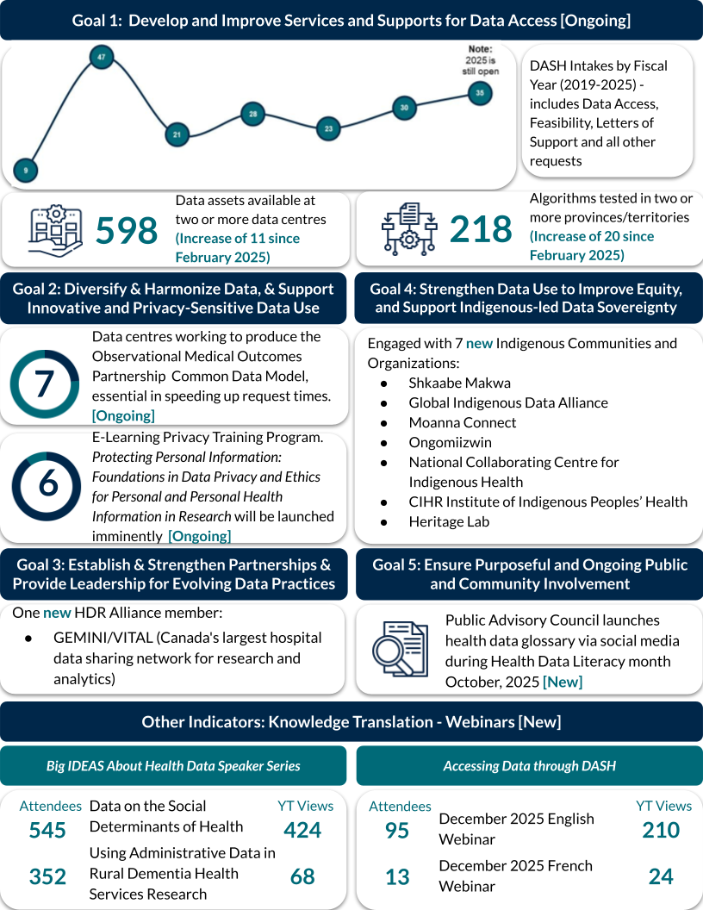

Section 2: Key Achievements on Strategic Commitments

Goal 1: Develop and Improve Services and Supports for Data Access

DASH Team
- At an in-person meeting in October 2025, the DASH Team discussed the structure and future state of Integrated Services (DASH & CAN-ASK). The Team explored the client experience from multiple client perspectives. A smaller task force is now developing a service blueprint for iteration.
- Office Hours continue to provide 1:1 meetings between researchers and an HDRN Canada expert for guidance on data access and methods planning.
- Two DASH webinars were delivered in December, including one co-delivered with DataNB.
- The Team is conducting annual consultations with member organizations to better understand and document their data access process. This work will inform new developments for the portal and its tools as well as resources to assist clients.

Management of DASH Projects
- There are 14 completed projects to date and three more are nearing completion. Currently, DASH has 25 active projects, with 16 of those at or beyond the data access request stage.

Goal 2: Diversify and Harmonize Data, and Support Innovative and Privacy-Sensitive Data Use

Development of New Distributed Analysis Methods
- Two meetings have been held with research teams who are officially requesting distributed analytics as part of their DASH projects.
- We are in the data collection phase for an official comparison of a distributed Cox regression (survival) vs meta analysis project based on an existing DASH study. This project requires simulations (which are underway) because we do not have access to the pooled version of the data for comparison. Results of this project will aid researchers to better understand impact when using Cox regression methods versus meta analysis.
- A distributed analysis pilot project using data held at Statistics Canada is also well underway.

MASK Machine-Learning De-Identification Tool Achieves Consistently High Performance Across Data and Sites
- ON and MB have confirmed the stable and reliable performance of MASK to de-identify free text across different samples of clinical notes using internal five-fold cross-validation for testing and training the model. This builds on the strong performance previously reported from the initial training/testing evaluation. AB continues with data annotation.
- Privacy and technical foundations for federated learning are being implemented across MB, ON and AB to enable secure multi-site model training while keeping sensitive data within each jurisdiction.
- An abstract describing this work has been submitted for presentation at the 2026 International Population Data Linkage Network (IPDLN) Conference.

Advancing Canadian Vocabulary Mapping to Support Observational Medical Outcomes Partnership (OMOP) Common Data Model (CDM) Implementation Across HDRN Canada and Beyond
- Five sites (ON, BC, NS, NB and PEI) completed mapping all ICD-10-CA and ICD-9 diagnostic codes for the two widely used comorbidity indices, the Charlson Comorbidity Index and the Elixhauser index. A validation study for these mappings is underway. These reusable mappings translate Canadian clinical terminology into OMOP standard concepts and are a foundational requirement for OMOP CDM implementation, ensuring that data from different systems and jurisdictions mean the same thing. This work will support OMOP implementation across HDRN Canada sites as well as implementation by other Canadian organizations and research teams.
- An abstract on this work was submitted to the 2026 IPDLN Conference.
- The team is actively coordinating vocabulary mapping across multiple Canadian institutions and teams with OMOP databases to reduce duplication of work, share resources, improve mapping quality and accelerate national OMOP implementation progress.

Data and Services are Expanding
- Our Quebec partner is offering Revenue Québec data for the first time via HDRN Canada.
- Saskatchewan is now offering researchers the ability to link an external data set (e.g., survey data that they collect) to the data centre’s routinely collected data.

A Major Milestone on CDMs
- We completed a study comparing results using “original” data with harmonized data put into the OMOP CDM format.
- The study showed perfect concordance between the two, and much speedier analysis time using the common data model.
- This was a small, limited study but confirms there is merit in pursuing data models as a major step in multi-regional research.

Goal 3: Establish and Strengthen Partnerships and Provide Leadership for Evolving Data Practices

Collaborative Plan Developed with International Partners
- We are already working with international partners (Health Data Research UK [HDR UK], Administrative Data Research UK [ADR UK] and Population Health Research Network [PHRN] in Australia) on plans for shared areas of interest, all of which align with our strategic priorities, including data harmonization, social license for use of data, and tools to support ease of data use.
- A paper outlining the findings of the joint (PHRN Australia and HDRN Canada) Social License workshop hosted at IPDLN 2024 was submitted to the International Journal of Population Data Science.
- Initial work to scope the potential for collaboration on AI in public engagement and health care has started.

Leading Pan-Canadian OMOP Common Data Model Collaboration
- HDRN Canada convened the first Pan-Canadian OMOP Common Data Model Engagement Event (November 17–18, 2025, in Toronto) to better understand the national OMOP landscape and lay the foundation for establishing a Canadian OMOP community. The two-day event brought together approximately 90 participants from academia, hospitals, government, research networks and industry across five provinces and internationally, and featured expert presentations, a plenary panel, tool demonstrations, and facilitated discussions on shared challenges and opportunities to collaborate. The event was very well received and there was strong appreciation for HDRN Canada’s leadership in convening the community.
- The event served as a catalyst to establish a Canadian chapter of the community focused on OMOP implementation and use, known as Observational Health Data Sciences and Informatics (OHDSI). HDRN Canada will act as a national convener, coordinating follow-up meetings and discussions to define the Canadian chapter’s aims, governance structure, objectives and key results.

Pragmatic Trials Training Program (PTTP)
- Western University, in partnership with HDRN Canada, will be hosting a local Clinical Trials Leadership Program. This new, competitive opportunity brings together a select cohort of clinicians located in London, Ontario to turn important clinical questions into well-designed, executable pragmatic and conventional trials. Selected participants will receive wraparound trial services and educational support, including expertise in methodology, epidemiology and statistics, as well as trial operations support and educational offerings.
- A trialist within the PTTP that we provide direct services to has been awarded CIHR funding to advance their 2-arm, parallel-group, registry-based, open-label, 2-sided superiority randomized trial comparing the clinical effects of a new generation of hemodialysis filters compared to conventional hemodialysis. The target sample is ~4,800 patients and the primary outcome is all-cause mortality. Over 200 patients were successfully randomized in the Vanguard phase of this trial, using several innovative elements to streamline recruitment.

The Health Data Research (HDR) Alliance
- The Working with Federated Data Forum meetings continued with:
  - A guest speaker from the University of Sheffield in the UK, presenting Reflections on the OMOP Common Data Model in Trusted Research Environment data preparation; new HDR Alliance member, GEMINI/VITAL, presesnting Harnessing clinical data for AI, trials and a Learning Health System – An overview of the VITAL Platform.
- The HDR Alliance Chair role transitioned to the Canadian Network for Observational Drug Effect Studies (CNODES) from the Canadian Longitudinal Study on Aging (CLSA) for 2026. Work continued on the Demonstrating Organizational and Research Impact initiative. The initiative has the following three planned deliverables:
  - Deliverable 1: Prepare tables that collate significant impacts of individual member organizations, including collaborations between members, using a custom framework that reflects the HDR Alliance Action Plan and aspects of the Declaration on Research Assessment (DORA) Framework.
  - Deliverable 2: Create a document that interprets and translates findings by themes of collective strengths and opportunities for collaboration.
  - Deliverable 3: Develop a series of promotional materials that feature strengths of the HDR Alliance members, aligned to the interests of government and funders
  - Members have completed their Deliverable 1 tables, and Deliverable 2 is in progress with expected completion in first quarter 2026.

Continued Collaboration with International Partners
- The Coordinating Committee of international partners (HDRN Canada, HDR UK, ADR UK and PHRN Australia) continued to meet monthly and advance a plan for collaboration and for submissions to IPDLN 2026. A rolling agenda was introduced for members to share updates, surface common challenges, and identify small, concrete opportunities for international collaboration.
- In an effort to share good practice and learning we have collaborated with data linkage partners in Canada, Australia and the UK to create a new International Data Access Tools Repository. Hosted by ADR UK, categories for tools currently include Interactive Data Discovery Tools; Signposting Support; and Good Practice Resources. We are in the process of inviting others to explore the repository and contribute more tools to it.

SPOR Canadian Data Platform (CDP) Advisory Committee
- The SPOR CDP Advisory Committee held its eighteenth meeting. Members provided feedback and input on the following items: data privacy tools, an update on the IDEA Strategy and an update on the MASK project.

Goal 4: Strengthen Data Use to Improve Equity, and Support Indigenous-led Data Sovereignty

Supporting the Development of a National Indigenous Data Sovereignty Network:

Collaborations with Indigenous scholars, organizations, community
- We co-hosted with Shkaabe Makwa (The Centre for Addiction and Mental Health [CAMH]) a National Indigenous Data Sovereignty and Governance Working Session in December, 2025. The event was well attended (50+ participants) and advanced the engagement of Indigenous scholars, organizational leaders, service providers and community members from across Canada in discussion about Indigenous research, research data, data sovereignty and governance. A highlight of the event was the presentation of the idea of a National Indigenous Data Sovereignty and Governance Network. The idea was well-received and positive feedback and support was given for moving forward with the development of the network.
- The Indigenous Data Team (IDT) Chair is engaging with Indigenous scholars, organizational leaders, and community members in other spaces: HDRN Indigenous Data Working and Learning Group, the IDEA Team, Ongomiizwin Indigenous Institute of Health and Healing (at the University of Manitoba), the National Collaborating Centre for Indigenous Health, the CIHR Institute of Indigenous Peoples Health and Heritage Lab.

Supporting Collaboration with Indigenous Data Sovereignty Networks Globally

Building a strong presence in the Global Indigenous Data Alliance
- We are collaborating with the Indigenous data network in New Zealand (Moanna Connect) and HDRN Canada to secure funding for Indigenous scholars, leaders and community from Canada to attend the next Global Indigenous Data Alliance (GIDA) meeting in February, 2026. We have 11 members of our Canadian cohort attending the meeting including representation from First Nations, Inuit and Métis Nations.
- We are planning a second National Indigenous Data Sovereignty and Governance Working Session in late Spring 2026 in Winnipeg, MB.

Building Capacity and Integrating Indigenous Perspectives, Knowledge and Understanding into Research:

Building capacity in research data centres
- The IDT chair co-led two workshops for faculty and staff at the Manitoba Centre for Health Policy (MCHP) on creating personal Land and Territory Acknowledgements.
- Twenty-Five faculty and staff at MCHP are enrolled in an Indigenous cultural safety training program, We Will Take Good Care of the People, developed by Ongomiizwin – Indigenous Institute of Health and Healing. The IDT team co-led pre/mid/post training check-ins and sharing circles for staff enrolled in the training.

Implementing our IDEA Strategies
IDEA Strategy 1: Learning/Unlearning
- Completed 18 months of IDEA Community of Practice Unlearning sessions with 75 percent of respondents to a participant survey strongly agreeing that the material shared was useful and relevant, leading to further disseminating their learnings in their host organizations.
- Created an HDRN Canada IDEA Unlearning Club Curriculum for the first six modules of learning and published these on the HDRN Canada website.
  - One completed module on Cultivating Safe Spaces is now available on HDRN Canada’s YouTube page.
- Worked to embed IDEA within the PTTP learning by creating a learning module on considering IDEA when selecting outcome measures.
- Completed an initial scan and curation of core, stretch and specialized IDEA competencies. The competencies are individual- and organization-level. We are now preparing for focus groups to socialize, pare down and properly curate the competencies
  - A workshop abstract was submitted to IPDLN 2026 to showcase this work
- Planning the creation of an e-learning module to cover IDEA competencies in administrative data space
IDEA Strategy 2: Facilitating IDEA in Data Research
- Two briefing notes were co-created, covering how IDEA can be embedded in HDRN Canada projects, the Pan-Canadian Concept Dictionary and the Common Data Models, . These present recommendations to staff working on infrastructure projects.
- Curated resources to guide researchers on how to embed IDEA within their research projects. These resources will be available through the DASH portal as well as shared with researchers who use the ‘Office Hours’ service.
IDEA Strategy 3: Cultivating Trust and Reciprocity in Community Partnerships
- Several work streams are underway to determine processes for considering public engagement in internal HDRN Canada work:
  - An environmental scan of HDRN Canada members’ knowledge and resources for implementing public engagement into internal processes is now complete.
  - A systematic literature review of non-academic grey literature on organizational processes for embedding IDEA and public engagement returned over 30 resources for analysis.
  - The final output will be a “question bank” following the continuum of internal projects to best consider public engagement and reciprocity.
IDEA Strategy 4: Providing Leadership and Advocacy in IDEA
- Completed a “Big IDEAs About the Data Research Ecosystem: Collective actions that would make data research more inclusive, diverse, equitable and accessible” Report in collaboration with HDRN Canada Executive and Leads Team members. This report will be shared with the HDR Alliance in the near future.
- Working toward creating an HDRN Canada Five Safes 2.0 Framework. This framework will build upon current privacy concepts and expand to community privacy, concepts of IDEA, community governance, public engagement and Indigenous Data Sovereignty.
- Two abstracts submitted to the IPDLN 2026 Conference, one on the Five Safes 2.0 Framework and one on the Safe Projects rubric being forwarded by the CAN-ASK Private Sector Tactical Team.
Publications
- The manuscript Understanding Inclusion, Diversity, Equity, and Accessibility in a distributed data network: Environmental scan within Health Data Research Network Canada was accepted for publication in the International Journal of Population Data Science (IJPDS).
- The manuscript Co-creating an Inclusion, Diversity, Equity, and Accessibility (IDEA) strategy in a Pan-Canadian health data research network is now complete and will be submitted to IJPDS.
Benchmarks
- The IDEA Team is creating an organizational IDEA benchmarking tool for use by distributed administrative data networks. Within this tool will be considerations for mentoring, improving diversity and skills matrices, embedding IDEA within infrastructure and communications, and potential additional topics.

Goal 5: Ensure Purposeful and Ongoing Public and Community Involvement

Private Sector Safeguards and Public Benefit Work for CAN-ASK
- An abstract was submitted to the IPDLN 2026 Conference on work of HDRN Canada to define private sector safeguards and public benefit as part of the CAN-ASK service. Public Engagement Team staff have been leading this work alongside the CAN-ASK team.
- A public-benefit and risk assessment tool to support decision making for private-sector projects has been drafted. Early development drew on consultation with the Public Advisory Council, Canadian data governance practices, international guidance, and IDEA and Indigenous Data Sovereignty principles.

Ongoing Dissemination and Follow-Up Work on the Foundational Paper on Public Trust and Data Literacy Developed in Collaboration with the Public Health Agency of Canada (PHAC)
- A joint webinar hosted with other key partners in the PHAC public trust and data literacy initiative (CHIMA and SFU) was held on October 20, 2025.
- A publication, Recommendations for building trust in health data systems: A qualitative study informed by patient and public engagement was submitted to BMJ Open.

Success Factor: Cohesive Network with Effective and Sustainable Operations

HDRN Canada 2025 Events Overview
- Over 2025, HDRN Canada held 15 public events (e.g., Big IDEAS about Health Data, DASH webinars) that had a combined total of 11,086 registrants and we increased the number of people following our events page on Eventbrite by 71% to 356. HDRN Canada now has >5,800 followers on LinkedIn.

Success Factor: Supportive and Engaged Legislative and Policy Ecosystem and Community of Data Users

Update on the pan-CANadian data Analytic Service for Knowledge users (CAN-ASK) Initiative
- The CAN-ASK Implementation Steering Committee and the four Tactical Sub-Teams continued to meet to develop the service.
- There are four active CAN-ASK projects:
  - Two projects with Canada’s Drug Agency that are continuations of past projects on Monitoring and Evaluation of Diabetes and Contraception. These projects are being done in collaboration with the Canadian Institute for Health Information.
  - A project with Immigration, Refugees and Citizenship Canada on health care use by immigrants compared with long-term residents.
  - A private-sector project with a signed non-disclosure agreement.

