HDRN Canada
IDEA Strategy

September 26, 2025

Table of Contents
HDRN Canada IDEA Strategy Background 3
Purpose 4
What did HDRN Canada want to see? 4
Potential Challenges 4
Proposed Strategies 6
1. Learning & Unlearning 6
2. Facilitating IDEA in Data Research 6
3. Cultivating Trust and Reciprocity with Community Partners 7
4. Providing Leadership and Advocacy to Drive IDEA 7
Summary & Next Steps 7

HDRN Canada IDEA Strategy Background
In HDRN Canada’s Strategic Plan (2021-2026, a commitment was made to develop an Inclusion, Diversity, Equity and Accessibility (IDEA) Strategy and Action Plan that defined what HDRN Canada’s role and responsibilities were towards IDEA. In the Fall of 2023, HDRN Canada launched a facilitated consultation process to co-create an IDEA strategy through consensus building, holding nine focus groups, eight individual interviews, six roundtables and countless conversations over the course of eight months. In total, we engaged 101 different people from HDRN Canada member organizations, staff and leadership to understand their visions, anxieties and priorities for advancing and implementing IDEA across our complex pan-Canadian network. The following is a high-level report on the facilitation process and four recommended strategies.
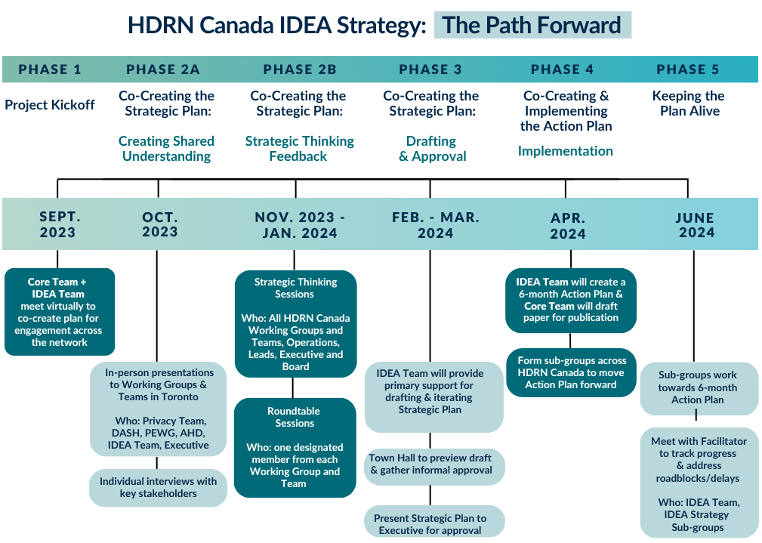

Purpose
The IDEA strategy development process was guided by three objectives:
- Identify how HDRN Canada can embed IDEA into its five strategic goals
- Identify shared roles and responsibilities for IDEA that can be adopted by HDRN Canada leadership, staff and member organizations to achieve greater shared accountability and ownership of IDEA
- Advance IDEA as it relates to reconciliation.

What did HDRN Canada want to see?
During the facilitation process we explored our collective vision for IDEA in a way that complimented HDRN Canada’s vision, mission, and values.. Seven action-oriented themes arose from the focus groups, interviews and roundtables:
- HDRN Canada lives and believes in IDEA
- HDRN Canada fosters IDEA in research
- HDRN Canada prioritizes community involvement for impact
- HDRN Canada enhances IDEA capacity through resources, tools and innovation
- HDRN Canada provides leadership in IDEA to transform the data landscape
- HDRN Canada partnerships demonstrate commitment to purposeful IDEA
- HDRN Canada supports the self-determination and sovereignty of Indigenous peoples
- HDRN Canada demonstrates commitment to reconciliation with Indigenous peoples.
By asking the question, “What do we want to see going on with IDEA in 2026?,” we were able to work backwards to identify strategies as well as potential challenges.

Potential Challenges
When asked what might pose challenges to HDRN Canada in achieving its IDEA goals, a number of themes emerged, summarized in this table:
Potential Challenge | Description
Ambiguity & Fear of Getting it Wrong | - Lacking expertise and confidence in implementing IDEA  - Hesitancy to act on IDEA independently out of concern for doing it wrong and the potential for negative consequences.
Low Prioritization & Under-resourcing | - Desire for clear direction from HDRN Canada’s leadership about prioritizing IDEA, navigating competing objectives and information about what resources are available.
Inadequate & Inconsistent Data Resources | - Capacity to support IDEA in research is impacted by data quality, collection standards and harmonization  - Importance of being realistic about HDRN Canada’s influence and power to change data quality and collection
Non-existent or Weak Partnerships with Communities | - Uncertainty about who HDRN Canada should partner with to bolster IDEA  - Concerns about building trust and maintaining good relations when doing multi-regional administrative data research studies with community partners
Entrenched Norms in Data Research Culture | - Bureaucratic, academic, health and government ecosystems that promote the status quo and limit the ability for transformative action  - Cultural norms that make the integration of IDEA daunting, challenging and unpredictable.

Proposed Strategies
Collectively, HDRN Canada identified actions that could mitigate these challenges and move the network towards a comprehensive, collective vision for IDEA. Thirteen themes emerged from the roundtable discussions and through iterative consultation, these themes were distilled into four strategies:
- Learning and Unlearning
- Facilitating IDEA in Data Research
- Cultivating Trust and Reciprocity with Community Partners
- Providing Leadership and Advocacy to Drive IDEA

Learning & Unlearning
Appropriate resources and dedicated time for learning at both the individual level and the organizational level are necessary to improve competency and capacity for IDEA. Recommendations for learning and unlearning include:
- Dedicating resources for IDEA training and knowledge sharing
- Developing safer and reflexive spaces where conversations and learning about personal and systemic biases can take place.

Facilitating IDEA in Data Research
Collectively, HDRN Canada can support, advocate for, and bolster efforts to integrate IDEA into existing and novel data use approaches and practices across the data research ecosystem. Objectives for facilitating IDEA in data research include:
- Understanding data gaps and supporting efforts to expand data assets in an equitable way;
- Having fulsome metadata to support researchers’ understanding of the data; and
- Having the right processes to support doing research in an equitable way.

Cultivating Trust and Reciprocity with Community Partners
Ensuring purposeful and ongoing public and community involvement is one of HDRN Canada’s five strategic goals. Two knowledge-building actions emerged that would strengthen the connection between IDEA and HDRN Canada’s public engagement work:
- For internal HDRN Canada work that advances data research infrastructure: seek appropriate feedback from systemically marginalized communities to reduce barriers to data access and use.
- For researchers using multi-regional population data: learn when and how to partner with community organizations.

Providing Leadership and Advocacy to Drive IDEA
Successfully implementing the previous strategies requires strong and clear leadership. We note this leadership comes not just from HDRN Canada’s Executive Committee, which is responsible for providing unified and explicit direction, but also from Team Leads with subject matter expertise who can help support HDRN Canada to carry out its work in ways that align with IDEA. In order to provide leadership and advocacy to drive IDEA, we need to:
- Ensure clear direction for and prioritization of IDEA work across HDRN Canada Teams is needed; and
- Continue building relationships with data providers and prioritize addressing IDEA-related issues related to administrative data collection, governance, and use.
As HDRN Canada continues to establish its role supporting innovation in data use and advocating for necessary legislative and policy change across the country, ongoing advocacy for IDEA-related change is necessary.

Summary & Next Steps
HDRN Canada is a complex pan-Canadian network whose work takes place across multiple member organizations, geographic regions and time zones. The dedication to the co-creation of this unique and groundbreaking IDEA Strategy is indicative of the collective organizational desire to enact change and create a more inclusive, diverse, equitable and accessible data research environment.
To ensure the strategy is implemented, we developed a complimentary Action Plan, which is currently being implemented. Learn more about HDRN Canada’s ongoing IDEA work here.

