HDRN Canada
Health Data Research Alliance Action Plan Framework

February 2026
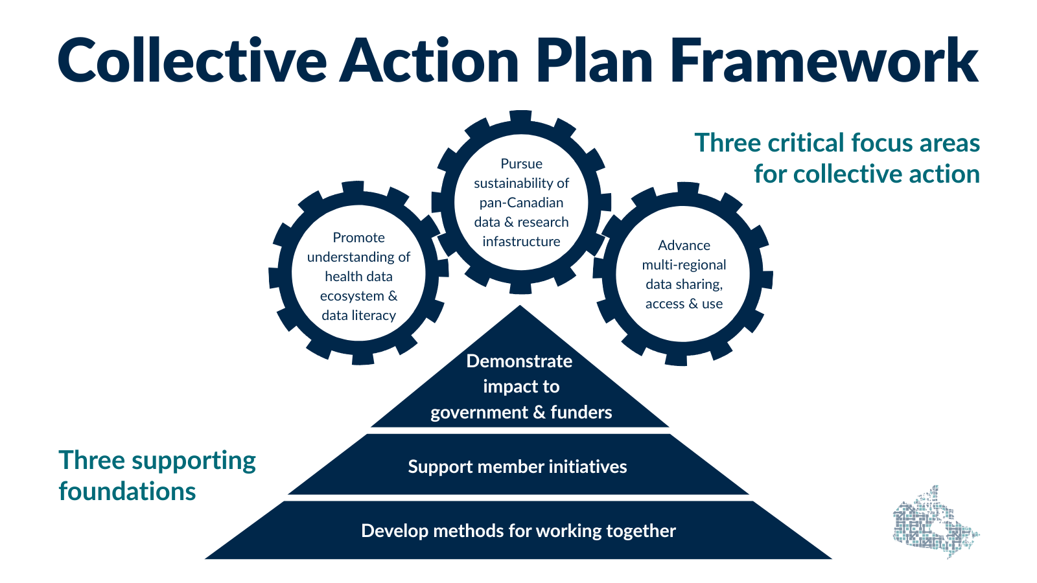
The HDR Alliance organizes its work across two layers:

Cross-cutting Enablers (How We Work):

Working together effectively (governance, coordination, communications)
We maintain a clear meeting rhythm and light governance to keep momentum between meetings. The Secretariat supports follow-through, and our communications leads network helps us align messaging and cross-promote work across member organizations.

Supporting and amplifying member initiatives
We create a practical space for members to surface initiatives, share tools and lessons learned, and identify opportunities to collaborate. Where it adds value, we connect related workstreams to accelerate progress and avoid duplication.

Demonstrating (individual and collective) impact to government and funders
We translate member activities into a clear narrative of value and results, using shared impact work to reflect both individual contributions and the “sum of our parts.” This helps strengthen credibility, inform priority-setting, and support coordinated engagement with external decision-makers.

Collective Focus Areas (What We Work on Together):

Promote understanding of the health data ecosystem and data literacy
We help make the Canadian health data landscape more navigable by mapping key players, relationships, and pathways for collaboration. We also support a clearer, shared understanding of how health data research works and how it can be used to improve health outcomes and equity.

Pursue sustainability of the pan-Canadian data and research infrastructure
We advance a shared position on the importance of stable, long-term infrastructure that enables high-quality, timely, multi-jurisdictional health and health equity research. This includes aligning around emerging needs such as AI readiness and cohort legacy planning, and strengthening how we communicate the case for investment.

Advance multi-regional data sharing access and use
We work to reduce barriers to multi-regional research by advancing methods, policies, and practical approaches that enable data use across jurisdictions. This includes collaboration on federated and distributed approaches, emerging data types, and tools that support consistent, secure and efficient access.

