HDRN Canada
Scientific Director and CEO’s Report
May 7, 2025

Table of Contents
Section 1: Organizational Performance Indicators Dashboard 3
Section 2: Key Achievements on Strategic Commitments 4
Goal 1: Develop and Improve Services and Supports for Data Access 4
Goal 2: Diversify and Harmonize Data, and Support Innovative and Privacy-Sensitive Data Use 5
Goal 3: Establish and Strengthen Partnerships and Provide Leadership for Evolving Data Practices 7
Goal 4: Strengthen Data Use to Improve Equity, and Support Indigenous-led Data Sovereignty 8
Goal 5: Ensure Purposeful and Ongoing Public and Community Involvement 10
Success Factor: Cohesive Network with Effective and Sustainable Operations 11
Success Factor: Supportive and Engaged Legislative and Policy Ecosystem and Community of Data Users 11
Abbreviations
AHD: Algorithms & Harmonized Data: A Working Group within HDRN Canada
CanPath: Canadian Partnership for Tomorrow’s Health: A large, longitudinal cohort
CDM: Common Data Model
CFI: Canada Foundation for Innovation
CIHI: Canadian Institute for Health Information
CIHR: Canadian Institutes of Health Research
DAI: Data Asset Inventory: One of the resources developed by HDRN Canada
DASH: Data Access Support Hub: A Working Group within HDRN Canada
IDEA: Inclusivity, Diversity, Equity, and Accessibility
ISQ: Institut de la statistique du Québec
MIG: Modelling and Informatic Group
OMOP: Observational Medical Outcomes Partnership: A widely used common data model that HDRN Canada is implementing
PAC: Public Advisory Council: An advisory body supported by HDRN Canada
PE: Public Engagement: A Working Group within HDRN Canada
PHAC: Public Health Agency of Canada
PTTP: Pragmatic Trials Training Program: A program hosted by HDRN Canada
TRE: Trusted Research Environment: Terminology for secure spaces where data analysis happens

Section 1: Organizational Performance Indicators Dashboard
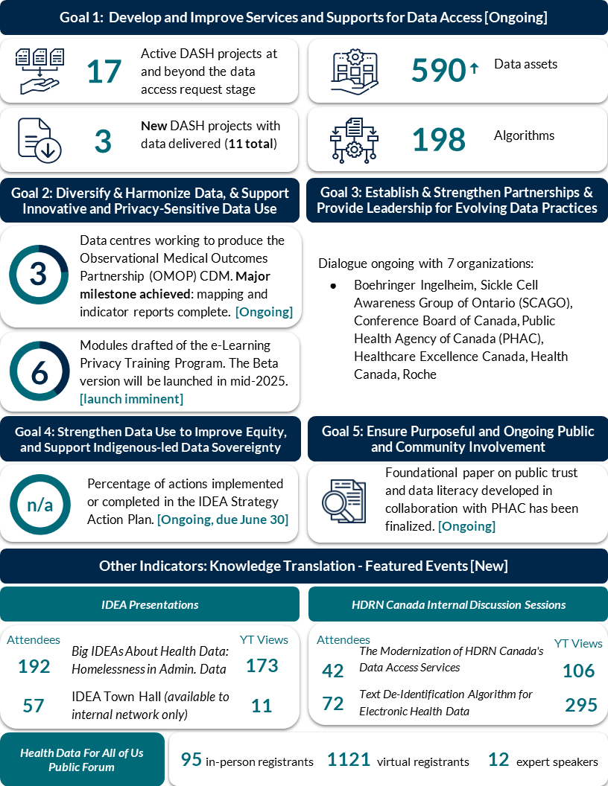
Note: Indicators are updated quarterly. Ongoing or new initiatives are denoted in square brackets.

Section 2: Key Achievements on Strategic Commitments

Goal 1: Develop and Improve Services and Supports for Data Access

Progress on DASH Requests
- The Data Access Support Hub (DASH) Working Group (WG) is currently supporting 17 data access requests (requests beyond feasibility assessment and intake process).
- From January 1, 2025, to March 31, 2025, there were 12 new intake form submissions for which DASH provided seven project feasibility assessments and cost estimates. The remaining submissions received project exploration support from DASH and/or were redirected to a pan-Canadian data centre.
- Five data access requests have been completed to date this fiscal year.

DASH Communications and Promotions Reaching Wide Audiences
- DASH and CanPath collaborated on an event on April 2, 2025, to promote the value of HDRN Canada partnerships and multi-regional research. The event was hosted by CanPath and more information is available on their website.
- Health Research Data Platform – Saskatchewan (HRDP-SK) is planning for and delivering several local events promoting their data access services.
- The Alberta SPOR Unit is collaborating with a researcher to highlight DASH services. The webinar on May 7, 2025 will highlight how HDRN Canada helped navigate the data access process across Canada and scale their research to a national level.
- DASH and the Modelling and Informatics Group (MIG) are collaborating on a webinar (and resources) to demonstrate the value of distributed analysis in multi-regional research. The event will be held on June 12, 2025 and information will be available on our website closer to the event.

Strong Presence Planned for the 2025 CAHSPR Conference
- DASH will participate in the Canadian Association for Health Services and Policy Research (CAHSPR) conference and present a poster on the network’s determination to “Build capacity across Canada to support data access for multi-regional research.”
- DASH and HDRN Canada are supporting a pre-conference workshop related to health workforce data in Canada at CAHSPR with the Canadian Institute for Health Information (CIHI), Health Workforce Canada and other organizations.

DASH Action Plan is Well Underway
- DASH presented at the March HDRN Canada Discussion Series on the evolution of DASH and the progress made on the DASH Action Plan to date.
- Focus areas include the user experience and the accessibility and ease of DASH forms. DASH will begin user testing on the enhanced query and intake form this spring.
- A sub-group of HDRN Canada members will support the development of an enhanced DASH user experience survey and process. The sub-group includes representation from DASH, the Partnerships Team, the Algorithms and Harmonized Data (AHD) Working Group, HRDP-SK and Health Data Nova Scotia.

Advancing Pan-Canadian Concept Dictionary to Help Researchers Plan Projects
- SAIL Databank has completed the prototype web platform for HDRN Canada, and user testing is currently being conducted by the AHD Working Group. In collaboration with IDEA Team, AHD is refining a concept template for the platform to enhance standardized data capture and improve discoverability for researchers.

Enhanced Workflow Developed
- The DASH and MIG have developed a platform to coordinate local data centre operations for DASH projects. PEI has volunteered to test this new workflow, which will help to automate DASH tasks and thereby make the process simpler and quicker for staff.

Goal 2: Diversify and Harmonize Data, and Support Innovative and Privacy-Sensitive Data Use

Harmonizing Terminologies for use in Common Data Models
- We mapped diagnostic and drug codes related to diabetes, contraception, pregnancy, and birth outcomes to standard vocabularies in the Observational Medical Outcomes Partnership (OMOP) common data model as part of the pan-CANadian data Analytic Service for Knowledge users (CAN-ASK) project, funded by Canada’s Drug Agency (CDA-AMC).
- This work advances pan-Canadian OMOP implementation and lays the foundation for faster, standardized analysis to support CDA-AMC’s Monitoring and Evaluation plans.

Pilot Sites Annotating Data to Optimize the MASK Machine-Learning Tool for De-Identifying Free Text Data
- In February, leads from the three pilot sites (Alberta, Manitoba, and Ontario) presented at the HDRN Canada Discussion Series, sparking interest in the project. An abstract that showcases the project’s progress was accepted for an oral presentation at the CAHSPR conference in May.
- The first phase of selecting records and labelling identifiable information is underway. Sites are collaborating to ensure consistent methods, while also considering regional differences in data, privacy legislation, and definitions of personally identifiable information.

Promotion of Distributed Analysis Methodology
- New methods of distributed data analysis are being developed, including Cox Regressions (survival analysis) and options to add weights to the analysis. The addition of weights was prioritized because two research teams using the DASH requested this methodological extension.
- Current information on available distributed analysis methods is being compiled into a Distributed Analysis Factsheet that will be available on the HDRN Canada website imminently.
- A pilot project using a Cox Regression is ongoing and may yield additional methodological learnings that would be shared with the network and researchers. This DASH study’s methodology considers the population from three provinces as one cohort and could provide unique learnings.
- A presentation was given to Institut de la statistique du Québec (ISQ) in Quebec (a Network member) and received buy-in for the organization to participate in a pilot project for distributed analyses with the DASH.

Promoting HDRN Canada’s Trusted Research Environments Expertise
- The Privacy and Communications Teams have finalized the one-pager summarizing the best practices of trusted research environments (TREs) across HDRN Canada. This resource provides a plain language description of what a TRE is, what safeguards are in place to ensure data security, and our member organizations’ roles and expertise with TREs. The one-pager will be available on the HDRN Canada website imminently.

Goal 3: Establish and Strengthen Partnerships and Provide Leadership for Evolving Data Practices

Pragmatic Trials Training Program (PTTP): All Learners Completed San’yas Training
- Supported 76 learners, staff, and mentors through a 10-week Anti-Racism Indigenous Cultural Safety Training Program (San’yas) and conducted cultural debriefs with all learners.

PTTP Hosted a Four-Day Virtual Conference
- Over 120 registered learners, mentors, and staff attended (day one peak of 90+ active viewers).​
- Showcased eight trials during the conference, and 24 individuals, including learners, mentors, and clinicians, served as panelists to ask questions and provide feedback on the trial protocols.​

The Health Data Research (HDR) Alliance Agrees to 2025 Priorities
- The HDR Alliance priorities for 2025 include:
  - Develop an approach for cross-promotion of network member activities
  - Continuing mapping the data ecosystem to understand opportunities for improvement
  - Continue hosting the Working with Federated Data Forum and produce 3-4 written use cases from this work.
  - Hold two themed meetings and produce a paper on each: 1) Demonstrating Organizational and Research Impact; and 2) Issues with TREs
- As part of the Working with Federated Data Forum members reviewed several proposed methods of data obfuscation/masking to securely share small cell counts and other summary statistics. A method was selected for a pilot project to be conducted with synthetic data in the near future.

International Partners Agree to Plan for Collaboration in 2025/26
- The international partners (HDRN Canada, Health Data Research (HDR) UK, Administrative Data (ADR) UK, and Population Health Research Network (PHRN) Australia) agreed to a Plan for Collaboration in 2025/26, including:
  - Three Collaborative Action Groups: 1) Data harmonization, 2) Tools to ease data use (e.g., data discovery tools, concept dictionary, phenotype library), and 3) Health data social licence. The health data social licence group (which HDRN Canada’s Public Engagement WG is involved in) has met once, the others will be meeting soon.
  - A virtual international partners meeting is being planned for Fall 2025. The objective of this meeting is to share progress, align priorities, and strengthen relationships across our organizations. It will bring together senior leadership and action group representatives to reflect on joint efforts and identify opportunities for deeper collaboration moving forward.
- Joint PHRN Australia/HDRN Canada social licence work will be presented at CAHSPR 2025.

Goal 4: Strengthen Data Use to Improve Equity, and Support Indigenous-led Data Sovereignty

Implementing the IDEA Strategies in our Strategic Plan

IDEA Strategy 1: Learning/Unlearning
- Establishing Core IDEA Competencies for anyone working in the administration data space.

IDEA Strategy 2: Facilitating IDEA in Data Research
- Agreement to create four briefing notes providing background and recommendations for incorporating IDEA into HDRN Canada infrastructure projects: data biographies, national concept dictionary, common data models, and phenotype libraries.

IDEA Strategy 3: Cultivating Trust and Reciprocity in Community Partnerships
- Leveraging newly formed project approval form to establish a process to ensure any internal HDRN Canada initiatives meaningfully consider concepts of IDEA and public engagement and create a feedback loop to establish co-learning and sharing success stories.

IDEA Strategy 4: Providing Leadership and Advocacy
- Bi-monthly meetings with sub-group, including members of the Executive Committee, Operations Team, Privacy Team, and Partnerships Team to create an engagement framework to prioritize initiatives and actions for HDRN Canada to move forward to further IDEA within the administrative data space.

The Big IDEAs About Health Data Webinar Series Continues to Draw Attention
- We hosted the second Big IDEAs About Health Data webinar presentation on Homelessness in Health Administrative Data, which had 192 live attendees and (so far) 199 views on YouTube.
HDRN Canada IDEA Sharing
- Hosted an IDEA Town Hall, which had 57 attendees and 13 views on the YouTube channel (presentation available to internal network only).
- Members of the IDEA Team will be presenting a poster at CAHSPR 2025 titled: Re-thinking Responsibilities to Population Data: Evolving Practices for Equity in Health Research.

Dr. Jennifer Walker Awarded $24M in Funding
- HDRN Canada Executive Committee member Dr. Jennifer Walker received $24 million in federal government funding to decolonize brain health assessment in Indigenous communities and support Indigenous-centred brain health assessment, education and supportive care.

Indigenous Data Team Collaborations
- Attended monthly planning meetings to support the Community Data Linkage research project being led by the Canadian Alliance for Healthy Hearts and Minds (CAHHM)
  - The CAHHM has revised their proposal and continues to engage in conversations regarding community approval. They are preparing to resubmit their DASH application with this detailed proposal.
- The IDT has strengthened its relationship with Amanda Fowler-Woods, an Indigenous health and Indigenous data sovereignty scholar. Early discussions include revisiting how HDRN Canada can be a supportive platform to bolster the Indigenous Data Sovereignty Network’s efforts in Canada.
- HDRN Canada and the First Nations Information Governance Centre (FNIGC) are revisiting a formalized partnership, with support from the IDT.
- IDT is exploring options for restructuring and its approach to engaging in Indigenous data sovereignty work nationally and internationally.

Goal 5: Ensure Purposeful and Ongoing Public and Community Involvement

Finalized the Foundational Paper on Public Trust and Data Literacy in Collaboration with the Public Health Agency of Canada (PHAC)
- The paper, which includes six recommendations for trustworthy data practices, has been shared with PHAC. Dissemination and design plans are underway, including a presentation at CAHSPR.

Strong and Engaged Public Advisory Council (PAC)
- The PAC continues to advise on various network initiatives, and many members were involved in planning for the 2025 Health Data for All of Us public forum, including the generation of key areas of concern and questions around AI to be addressed at the forum. Two PAC members are speaking as part of the event’s keynote panel and a second plenary session.
- With the uncertainty regarding future funding of the SPOR CDP from CIHR, the varying levels of engagement of PAC members and their membership term status, we are considering whether to run the summer 2025 PAC recruitment process or wait until we have more clarity.
Development of Communications Products on Key PE initiatives
- PAC members are making significant progress on a plain language glossary of health data-related terms. The next phase, which includes resource design and dissemination, is now underway.
- Two planned publications summarizing joint health data social licence work undertaken in collaboration with PHRN Australia are underway.
Health Data for All of Us: A Public Dialogue on AI in Health Public Forum
- The program for the 2025 public forum is finalized. The agenda includes diverse topics and presenters focused on the role of AI in health
- There is significant interest in the forum from researchers/academics, policymakers, and patient partners, with 95 in-person and 1121 virtual registrants as of April 10, 2025. A current challenge is a low number of registrants from community groups (which is the target audience for the event) – targeted communications are now underway.

Success Factor: Cohesive Network with Effective and Sustainable Operations

Summative Evaluation Underway
- A company, Three Hive Consulting, is engaged to undertake the evaluation and a comprehensive Evaluation Plan is in development. Three Hive Consulting is an Indigenous-owned consulting firm that specializes in the non-profit, government and healthcare sectors.

Engaged in Additional Health Data Ecosystem Opportunities
- Innovation, Science and Economic Development Canada (ISED) is inviting eligible proponents to submit non-binding Statements of Interest to the AI Sovereign Compute Infrastructure Program. This is not a funding opportunity, but is an opportunity to state HDRN Canada’s AI needs and potential contributions, for example as articulated in our CFI proposal. We are writing a submission so that HDRN Canada’s interests, and those of Network members, are known and incorporated into future ISED’s planning and program design for a future call on sovereign compute infrastructure.

Ensuring Sustainability of HDRN Canada
- HDRN Canada is committed to completing the following two activities by September 30, 2025:
  - Review HDRN Canada’s not-for-profit bylaws and propose a governance structure that supports long-term sustainability
  - Develop a funding strategy, based on the governance structure, that is designed to create diversified funding streams to support long-term sustainability

Success Factor: Supportive and Engaged Legislative and Policy Ecosystem and Community of Data Users

The pan-CANadian data Analytic Service for Knowledge users (CAN-ASK) Initiative is Expanding:
- We completed several deliverables for CDA-AMC on time, including:
  - Monitoring and Evaluation of Diabetes and Contraception: Draft Indicator Specifications
  - Monitoring and Evaluation of Diabetes and Contraception: 2018/19 to 2022/23 Indicator Results and Output Tables
- Provided a proposed Statement of Work, including cost estimate to Boehringer Ingelheim (BI) for a project on metabolic dysfunction-associated steatohepatitis (MASH). Meeting with BI representatives in late April to discuss the work.
- In active discussions with a number of potential requestors, including Sickle Cell Awareness Group of Ontario, Conference Board of Canada, Public Health Agency of Canada, Healthcare Excellence Canada, Health Canada, and Roche.

HDRN Canada Vision on a Page
- In response to the strategic recommendations from Santis Health, HDRN Canada is developing a vision on a page. This will be a valuable resource, both as an internal tool to reinforce our vision and mission, and as an external tool to aid discussions with our partners on what makes HDRN Canada exceptional.

