HDRN Canada
Scientific Director and CEO’s Report
August 20, 2025

Table of Contents
Section 1: Organizational Performance Indicators Dashboard 3
Section 2: Key Achievements on Strategic Commitments 3
Goal 1: Develop and Improve Services and Supports for Data Access 3
Goal 2: Diversify and Harmonize Data, and Support Innovative and Privacy-Sensitive Data Use 5
Goal 3: Establish and Strengthen Partnerships and Provide Leadership for Evolving Data Practices 6
Goal 4: Strengthen Data Use to Improve Equity, and Support Indigenous-led Data Sovereignty 8
Goal 5: Ensure Purposeful and Ongoing Public and Community Involvement 10
Success Factor: Cohesive Network with Effective and Sustainable Operations 11
Success Factor: Supportive and Engaged Legislative and Policy Ecosystem and Community of Data Users 12
Abbreviations
AHD: Algorithms & Harmonized Data: A Working Group within HDRN Canada
CanPath: Canadian Partnership for Tomorrow’s Health: A large, longitudinal cohort
CDM: Common Data Model
CFI: Canada Foundation for Innovation
CIHI: Canadian Institute for Health Information
CIHR: Canadian Institutes of Health Research
DAI: Data Asset Inventory: One of the resources developed by HDRN Canada
DASH: Data Access Support Hub: A Working Group within HDRN Canada
IDEA: Inclusivity, Diversity, Equity, and Accessibility
OMOP: Observational Medical Outcomes Partnership: A widely used common data model that HDRN Canada is implementing
PAC: Public Advisory Council: An advisory body supported by HDRN Canada
PE: Public Engagement: A Working Group within HDRN Canada
PHAC: Public Health Agency of Canada
PTTP: Pragmatic Trials Training Program: A program hosted by HDRN Canada
TRE: Trusted Research Environment: Terminology for secure spaces where data analysis happens

Section 1: Organizational Performance Indicators Dashboard
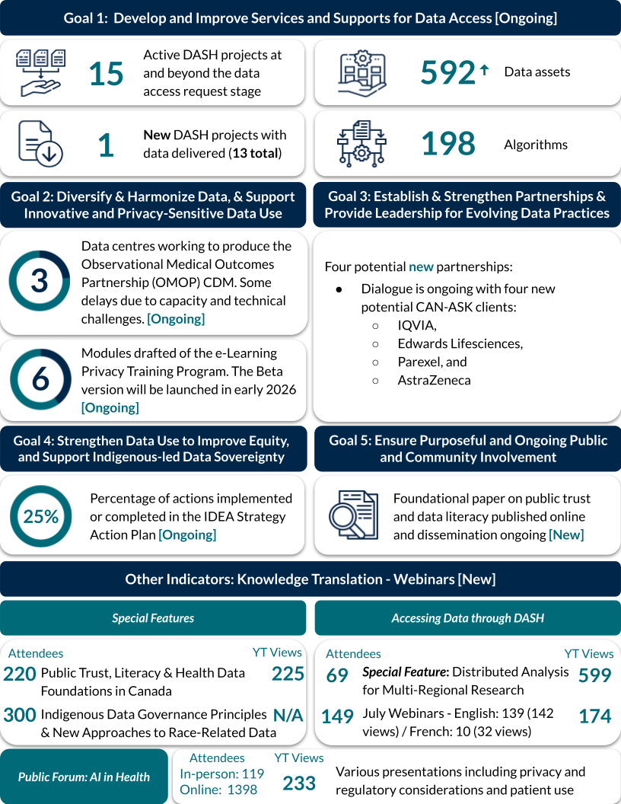
Note: Indicators are updated quarterly. Ongoing or new initiatives are denoted in square brackets.

Section 2: Key Achievements on Strategic Commitments

Goal 1: Develop and Improve Services and Supports for Data Access

Progress on DASH Requests
- The Data Access Support Hub (DASH) Working Group (WG) is currently supporting 15 full data access requests (requests beyond feasibility assessment and intake processes).
- Since January 1, 2025, the DASH has received 20 new intake form submissions. Of these, five are currently active, eleven are on hold, and four are closed. The DASH expects to see many more projects receiving feasibility support as the Fall Canadian Institutes of Health Research (CIHR) grant application deadline approaches.
- The DASH is improving the support offered to researchers by implementing new case manager and data scientist roles to its service design, in alignment with CAN-ASK services. Projects are already benefiting from this new approach.

DASH Communications and Promotions Reaching Wide Audiences
- HDRN Canada launched a new Office Hours service. Office Hours offer one-on-one advice from scientists who provide personalized support and answer questions about methods, analytic services, harmonized data and other HDRN Canada resources to help academics write a successful grant application.
- The DASH presented a poster titled Building Capacity Across Canada to Support Data Access for Multi-regional Research and co-organized a pre-conference workshop on health workforce data in Canada with the Canadian Institute for Health Information (CIHI), Health Workforce Canada and other organizations at the Canadian Association for Health Services and Policy Research (CAHSPR) Conference in May 2025.
- The DASH co-delivered the Distributed Analysis for Multi-regional Research webinar with the Modelling and Informatics Group in June 2025. The webinar was very well attended, with 165 live attendees and 583 views on HDRN Canada’s YouTube channel (as of August 5, 2025). The DASH also collaborated with multiple WGs and Teams to support the launch of new online resources for distributed analysis.
- The DASH co-delivered two webinars with ICES in July 2025 on data access services available for multi-regional research and resources and tools available to researchers to support them with grant applications.

Modernization of Forms
- The DASH launched its modernized intake form and new query form on August 1, 2025. This form was designed to improve the experience of researchers using DASH services. The form features a new design and is founded on user experience principles.
- The DASH is working towards modernizing their online portal of centralized forms. The next planned update is the feasibility assessment and cost estimate section of the DASH Portal.

User Experience
- DASH launched a user experience group which will focus on enhancing the information collected about the user experience of researchers using DASH services, with the goal of informing program evaluation and improving the existing interim and end-of-project quantitative DASH user surveys.

CanReview Strategic Relationship
- Launching in summer 2025, CanReview is an online pan-Canada resource enabling use of just one research ethics board (REB) review for multi-regional clinical trials.
- Over the past few months HDRN Canada’s Partnerships and Privacy Teams began building a strategic relationship with the CanReview team to see if this resource can be expanded to include multi-regional research using administrative data.
- The Privacy Team completed a scoping exercise of REB legislative requirements (i.e., identifying regions where REB review must be completed within a province/territory) and identified key contacts for REB approvals in each province/territory.

Goal 2: Diversify and Harmonize Data, and Support Innovative and Privacy-Sensitive Data Use

Training MASK Machine-Learning Tool Locally to De-Identify Free Text Data
- The Manitoba and Ontario pilot sites have begun using locally annotated clinical notes to train and fine-tune the MASK tool.
- The final distributed learning phase of the project will enable sites collaboratively to enhance site-specific MASK models to build a more generalizable tool without sharing raw data. This innovative approach introduces unique privacy challenges and the team is developing recommendations for review by privacy teams to safeguard privacy and mitigate risks.
- The distributed learning phase will require approval to share model parameters at each site. The project working group has developed a federated learning project plan that will be shared with stakeholders at each site who will provide this approval.

Pan-Canadian Concept Dictionary Prototype Platform
- SAIL Databank completed configuring a Pan-Canadian Concept Dictionary (PCCD) prototype, including integration of a standardized concept template developed by the AHD WG.The PDDC Platform will improve understanding and use of data and is ready for piloting.
- The pilot will assess the usability and value of the PCCD as a centralized, collaborative repository for research constructs, such as definitions, algorithms, and methodology from HDRN Canada data centres and partners and will inform future improvements and full implementation planning.

Privacy-Related Resources Underway
- The development of the e-learning privacy training resource has picked up pace and there is now draft content for seven of the nine planned modules. We continue to aim for a January 2026 beta version release of this resource.
- Updates were completed on the Data Sharing Agreement Checklist resource available on the HDRN Canada website. This is a comprehensive tool that provides detailed information for each data sharing partner on what is needed for an organization sharing data and the trusted research environment or steward receiving the data.

Goal 3: Establish and Strengthen Partnerships and Provide Leadership for Evolving Data Practices

Advancing Pan-Canadian Collaboration on the Observational Medical Outcomes Partnership (OMOP) Common Data Model
- We are leading the planning for a pan-Canadian engagement event, which will be held in November 2025, to support national collaboration on the Observational Medical Outcomes Partnership (OMOP) common data model. The event will lay the groundwork for establishing the first Canadian chapter of the global OMOP community and will help to define HDRN Canada’s leadership role in the national OMOP community.
- A program committee is guiding planning and includes clinicians, data experts and HDRN Canada operations team members.
- We are actively engaging with organizations across the country to build interest, better understand the current landscape of OMOP adoption in Canada and explore opportunities for sponsorship and co-hosting.

Completion of a Distributed Analysis Pilot Project
- This project involved distributed analysis across three provinces and looked at time to event analysis (Cox regression) for risks for COVID. This is the first test of this analytic method for an HDRN Canada DASH project.
- The project involved significant work to have the three provinces comfortable with the distributed analysis approach, ensure accurate understanding of the analytical components and to optimize the code to run the analysis.
- The completion of this project provides valuable insight for HDRN Canada for future DASH projects. Cox regression is now listed on the HDRN Canada website as a supported method and resources are provided to researchers to aid their understanding and use of this distributed analysis method.

Working with Federated Data: Small Cell Methods
- The Privacy Team is providing privacy policy guidance for work on small cell research methods using federated analysis. The Privacy Team will continue to support this work by preparing a briefing note on privacy considerations in the next quarter.

The Health Data Research (HDR) Alliance Action Plan
- The HDR Alliance held its first themed meeting on ‘Demonstrating Organizational and Research Impact’ leading to a new Organizational and Research Impact project. A Framework for reporting organizational and research impact was created based on the Declaration on Research Assessment (DORA) Framework, with modifications to accommodate the range of roles our members play in the health and research ecosystem. The framework covers the three critical focus areas for collective action from our Action Plan (AP).
  - AP Item 1. Foster Multi-Regional Data Sharing, Access and Use
  - AP Item 2. Promote Understanding of Health Data Ecosystem and Data Literacy
  - AP Item 3. Pursue Sustainability of pan-Canadian Data and Research Infrastructure
- The final deliverable will be a series of promotional materials that feature strengths of the HDR Alliance members and inputs into future HDR Alliance Action Plans.
- The Working with Federated Data Forum continued with sessions on a pragmatic trial use case, national small cells and updates on the distributed analysis and small cells pilot projects.
Continued Collaboration with International Partners
- The international partners (HDRN Canada, Health Data Research (HDR) UK, Administrative Data (ADR) UK and Population Health Research Network (PHRN) Australia) continued to meet monthly and are developing a plan for collaboration in 2025/26.
- A virtual international partners senior leadership meeting is booked for Fall 2025. The objective of this meeting is to share progress, align priorities and strengthen relationships across our organizations. We will also discuss plans for IPDLN 2026.
SPOR Canadian Data Platform (CDP) Advisory Committee
- The SPOR Canadian Data Platform Advisory Committee held its 16th meeting in June, 2025. Members provided feedback and input on the following items: a special members-only session with HDRN Canada’s summative evaluators, Three Hive Consulting; the distributed analysis pilot projects; feasibility study guidelines; and a Public Engagement Working Group/Public Advisory Council update.

Pragmatic Trials Training Program (PTTP): Advancement of Trial Leader Protocols
- Over 20 trial leaders have submitted draft protocols to the Pragmatic Trials Training Team to be reviewed by fellow peers and seasoned pragmatic trialists. Several of the trial leaders leveraged the internal draft protocol deadline as a push to prepare for Fall CIHR grant deadlines. The feedback provided will strengthen the trial leaders grant applications.
- The goal is for all trial leaders to have a robust, research ready protocol complete by the end of year 2. The submission of year 1 draft protocols allows us to evaluate 1) how the trials have changed since their initial application, 2) how trial leaders have incorporated curriculum modules/resources/teachings in year 1 and 3) highlights areas of focus for year 2.

Goal 4: Strengthen Data Use to Improve Equity, and Support Indigenous-led Data Sovereignty

Implementing the IDEA Strategy Components of our Strategic Plan:
IDEA Strategy 1: Learning/Unlearning
- Completed 12 months of the Community of Practice Unlearning Club with continued interest and engagement. There is a desire to expand this learning to the Public Advisory Council (PAC) and as part of the HDRN Canada staff onboarding process.
- A needs assessment survey has been prepared and will be distributed to members in the Fall.
- Curation and refinement of potential core competencies continues.
IDEA Strategy 2: Facilitating IDEA in Data Research
- Co-created and completed the first IDEA-informed briefing note on the Pan-Canadian Concept Dictionary with input from across the network.
- The second briefing note on Common Data Models is being structured and engagement on this will begin shortly
- The IDEA Team presented a well-received poster at CAHSPR on considerations for embedding IDEA in administrative data infrastructure projects.
IDEA Strategy 3: Cultivating Trust and Reciprocity in Community Partnerships
- An environmental scan is prepared and will be distributed in the Fall alongside the needs assessment survey.
- Pilot organizational IDEA initiatives are incorporated into HDRN Canada project proposal documents and are also being incorporated in CAN-ASK working plan processes.

The Big IDEAs About Health Data Webinar Series Continues to Draw Attention:
- The second year of the Big IDEAs About Health Data webinar series finished with a highly attended talk on Race-Related Data and Indigenous Data Sovereignty with 300 live attendees and over 700 registrants. The webinar series YouTube page now has over 3,000 total views.
Interest in HDRN Canada’s IDEA Unlearning Club Content Grows:
- Through the current Unlearning Club as well as through content sharing at conferences there has been increasing interest in expanding beyond the IDEA Community of Practice. The refined learning schedule will be posted on our website with co-created mini-modules to follow. This is the first step in creating an asynchronous IDEA in administrative data learning module.

Goal 5: Ensure Purposeful and Ongoing Public and Community Involvement

Foundational Paper on Public Trust and Data Literacy
- Dissemination and follow-up work on the foundational paper on Public Trust and Data Literacy in collaboration with the Public Health Agency of Canada (PHAC) is underway.
  - Dissemination of the paper (with a focus on the six recommendations for trustworthy data practices) so far included a public webinar and oral presentation at the 2025 CAHSPR conference.
- Planned follow-up work includes a publication to be submitted to a peer-reviewed journal (with two Public Advisory Council (PAC) members on the writing team) and a joint webinar/presentation with other key partners in the PHAC public trust and data literacy initiative.
Strong and Engaged Public Advisory Council:
- HDRN Canada hosted a successful face-to-face PAC meeting attended in-person by all but two PAC members. Key agenda items included participation in HDRN Canada’s summative evaluation and priority setting.
- PAC priorities were defined at this meeting and action planning is now underway for the coming year. Priorities include meaningful involvement in upcoming funding applications, private sector access to health data and equity, diversity, inclusion and accessibility.
- The PAC Chair appreciated meeting with the Board at their May meeting and welcomed their advice and commentary. The PAC, in collaboration with the Patient Engagement (PE) Team, is now looking at ways to improve our advocacy and engagement
- A lack of PAC representation from the territories has been identified and targeted recruitment is underway for one to two members from this region.
Development of Communication Products on Key Patient Engagement initiatives
- PAC members are continuing to make significant progress on a plain language glossary of health data-related terms. A communication plan for this work is defined (social media posts, short videos and images) and our target is to disseminate in October for health literacy month.
- Three planned publications summarizing joint health data social licence work undertaken in collaboration with PHRN Australia are near finalized (two plain language publications prepared for The Conversation and one research article prepared for International Journals of Population Data Science) with the aim to submit during summer 2025.

Health Data for All of Us: A Public Dialogue on Artificial Intelligence in Health Public Forum
- HDRN Canada’s third public forum was a huge success with 119 in-person attendees, including representation from CIHR, and 1398 registered to attend online (more than 450 of whom joined throughout the day).

Public Engagement (PE) Team Continues to Support PAC and all Major PE Initiatives
- This includes the development of a “toolkit” to support data centers in setting up their own advisory councils, which is aligned with the capacity-building workstream as identified in the PE Strategy
- Re-structuring of PE Team meetings (including monthly, instead of bimonthly, meetings and more collaboration in agenda-setting/chairing meetings from full membership) to support momentum

Success Factor: Cohesive Network with Effective and Sustainable Operations

Summative Evaluation Initial Draft Provided:
- The external evaluators prepared a draft of their summative evaluation report to HDRN Canada and the report is being refined based on HDRN Canada’s feedback. The network will carefully review the recommendations stemming from the final evaluation report to determine concrete steps for improvement.

Connection, Communication and Collaboration:
- A two-day in-person cross-working group and team meeting is being planned for October 2025, in Montreal. This is a key opportunity for working groups and teams to discuss cross-cutting projects and priorities and has been a successful event in the past by fostering strong relationships, enhancing communication and boosting network productivity.
- HDRN Canada Communications Team launched two new external newsletter editions of Data Points (May and June) and internal newsletter editions of Inside HDRN Canada to promote internal communications across the Network.

Success Factor: Supportive and Engaged Legislative and Policy Ecosystem and Community of Data Users

Update on the pan-CANadian data Analytic Service for Knowledge Users (CAN-ASK) Initiative
- A CAN-ASK Implementation Steering Committee and four Tactical Teams were convened and held kickoff meetings. The Steering Committee will meet quarterly to coordinate implementation activities, provide strategic input and guide overall progress. The Tactical Teams and their goals are as follows:
  - Costing, Contracting & Funding: Refine costing models and support streamlined approaches to contracting and funding.
  - Engagement: Lead service promotion, communications and engagement with clients and the public.
  - Operational Procedures & Tools: Develop standardized tools and procedures aligned with the project life cycle.
  - Private Sector Safeguards: Finalize safeguards and principles for responsible engagement with the private sector
- We have received four intake forms and completed three preliminary feasibility assessments for potential CAN-ASK projects for a mix of public- and private-sector clients. There is one confirmed request with Canada's Drug Agency (CDA-AMC) moving into contracting that is a continuation of Monitoring and Evaluation of Diabetes and Contraception.
- Challenges/Risks
  - Despite having completed feasibility including cost estimates for several potential CAN-ASK clients, only CDA-AMC has proceeded to contracting. One possible reason may be that there is considerable variation in how data centres cost the same project, with the resulting client quote being potentially cost prohibitive for multi-regional work.
  - The Operational Procedures & Tools tactical team is working to find cost-saving efficiencies, while the Costing, Contracting & Funding tactical team is exploring alternative funding models.

Submitted Statement of Interest to the AI Sovereign Compute Infrastructure Program Call by Innovation, Science and Economic Development (ISED) Canada
- HDR Alliance members HDRN Canada, the Canadian Longitudinal Study on Aging and the Canadian Network for Observational Drug Effect Studies, together with ICES, submitted a joint Statement of Interest to ISED’s call emphasizing our critical role with respect to the health data and research component especially with regards to secure research environments, data governance, data management and public, patient and community partnerships. This submission provides highlights of our expertise and capabilities and the key role of this new infrastructure for health data and research.

