HDRN Canada
Scientific Director and CEO’s Report
November 5, 2025

Table of Contents
Section 1: Organizational Performance Indicators Dashboard 3
Section 2: Key Achievements on Strategic Commitments 4
Goal 1: Develop and Improve Services and Supports for Data Access 4
Goal 2: Diversify and Harmonize Data, and Support Innovative and Privacy-Sensitive Data Use 5
Goal 3: Establish and Strengthen Partnerships and Provide Leadership for Evolving Data Practices 6
Goal 4: Strengthen Data Use to Improve Equity, and Support Indigenous-led Data Sovereignty 8
Goal 5: Ensure Purposeful and Ongoing Public and Community Involvement 10
Success Factor: Cohesive Network with Effective and Sustainable Operations 11
Success Factor: Supportive and Engaged Legislative and Policy Ecosystem and Community of Data Users 12
Summary of Board Follow-up Action Items 13

Abbreviations
AHD: Algorithms & Harmonized Data: A Working Group within HDRN Canada
CanPath: Canadian Partnership for Tomorrow’s Health: A large, longitudinal cohort
CDM: Common Data Model
CFI: Canada Foundation for Innovation
CIHI: Canadian Institute for Health Information
CIHR: Canadian Institutes of Health Research
DAI: Data Asset Inventory: One of the resources developed by HDRN Canada
DASH: Data Access Support Hub: A Working Group within HDRN Canada
IDEA: Inclusivity, Diversity, Equity, and Accessibility
OMOP: Observational Medical Outcomes Partnership: A widely used common data model that HDRN Canada is implementing
PAC: Public Advisory Council: An advisory body supported by HDRN Canada
PE: Public Engagement: A Working Group within HDRN Canada
PHAC: Public Health Agency of Canada
PTTP: Pragmatic Trials Training Program: A program hosted by HDRN Canada
TRE: Trusted Research Environment: Terminology for secure spaces where data analysis happens

Section 1: Organizational Performance Indicators Dashboard
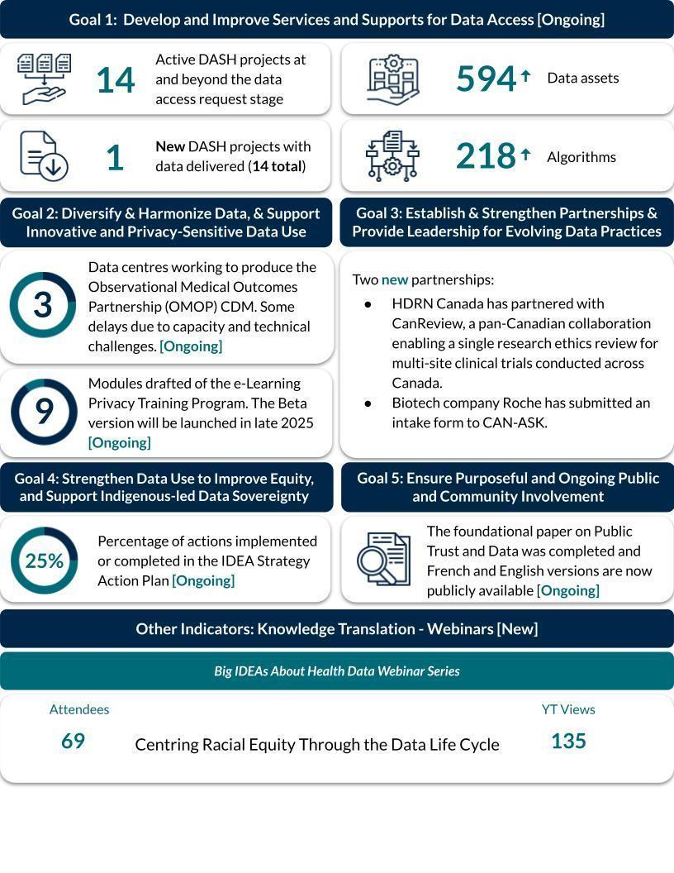
Note: Indicators are updated quarterly. Ongoing or new initiatives are denoted in square brackets.

Section 2: Key Achievements on Strategic Commitments

Goal 1: Develop and Improve Services and Supports for Data Access

Multi-Regional Research and Data Services:
- DASH & CAN-ASK are joining forces to align services for data access to provide a seamless and integrated client experience. To support this, the Executive Committee has decided to integrate DASH and CAN-ASK under the leadership of Anne Hayes, and with ongoing collaboration from Jordan Hunt. The integration will be guided by Executive sponsors Brent Diverty, Michael Schull/Charles Victor and Ted McDonald.
- The new team will form a planning and delivery task force initially composed of Executive Management Team (EMT) members, DASH and the Partnerships Team to help implement the new organizational structure. Teams will be consulted along the way.
- This new aligned service will continue to focus on improving support and services for multi-regional data, for diverse stakeholders in the health data ecosystem. This includes continuing to understand the user experience of clients, expanding tools and services, increasing our clientele, and advancing leadership in methodological innovation.

Management of Active DASH Projects:
- The DASH completed another project this quarter for a total of 14 completed projects to date. Currently, DASH has 20 active projects, of which 14 are formal Data Access Requests.
- The summer months were exceptionally busy, with 21 new project submissions (intakes) recorded between July 1 and September 30, 2025—a significant increase compared to the same period last year when there were only nine. During this time, the data centres also completed 18 feasibility assessments and cost estimates.

Modernization of the Online DASH Portal:
- The DASH launched its modernized intake form and new query form on August 1, 2025. This form was designed to improve the experience of researchers using DASH services. The form features a new design and is founded on user experience principles.
- The DASH is modernizing its online portal and centralized forms. As the work continues to evolve, there will be opportunities to integrate and harmonize the platform for all clients from the DASH and CAN-ASK portfolios.

User Experience Working Group:
- A user experience working group has developed a qualitative interview guide to gather in-depth user experience information from clients. The first qualitative interview with a researcher is planned for November.

Goal 2: Diversify and Harmonize Data, and Support Innovative and Privacy-Sensitive Data Use

Locally Trained MASK Machine Learning Tool Achieves Strong Performance in Free-Text De-Identification:
- The Ontario and Manitoba pilot sites have successfully trained MASK on their own data and in testing are achieving strong results across key performance measures for de-identifying personal information in clinical notes.
- The next phase will use federated learning, an innovative approach that allows multiple sites to train a shared machine learning model without moving or sharing sensitive data. As this is the first time sites are using federated learning, the team is exploring the best methods to ensure strong privacy safeguards across sites and provide privacy review teams with confidence that sensitive information is protected.

Expanding Site Participation in Advancing Observational Medical Outcomes Partnership (OMOP) Common Data Model Implementation:
- New sites (NS, NB and PEI) are gaining exposure to the OMOP Common Data Model and contributing to collective efforts to map Canadian clinical coding systems (e.g., ICD-10-CA diagnostic codes) to OMOP standard vocabularies. This work is fundamental to implementing OMOP and offers an accessible entry point for participation in OMOP implementation, since it does not require direct access to local data.
- Current mapping work is focused on diagnostic codes used in widely applied comorbidity indices. Contributing to this shared effort builds expertise and establishes processes that will support future mapping of additional coding systems, including for codes that vary across sites, such as physician billing codes. Further, these shared mappings will be used across participating data centres and made available to other organizations in Canada implementing OMOP.

Goal 3: Establish and Strengthen Partnerships and Provide Leadership for Evolving Data Practices

Leading Pan-Canadian OMOP Common Data Model Collaboration:
- We have secured a diverse group of speakers from across Canada and internationally for the upcoming Pan-Canadian OMOP Engagement Event (November 17–18 in Toronto). Interest in the event has been high, with registration reaching full capacity well ahead of time, underscoring the growing momentum around OMOP implementation nationally.
- Engagement in the lead-up to the event has helped us map the national OMOP landscape, strengthened organizational connections, and elevated awareness of HDRN Canada, positioning us nationally and internationally as a convener and leader in this space.

Significant progress on the Pragmatic Trials Training Program (PTTP):
- Now in Year 2, the weekly educational modules are in full swing (now being created with the support of various AI tools).
  - Thus far, Year 2 modules have explored differentiating explanatory and pragmatic intents and crafting feasible, partnership-driven research questions. They’ve advanced through key design principles, including outcome selection, intervention development, randomization methods and operationalization, with emphasis on equity, Indigenous data sovereignty and real-world applicability. The most recent module integrates statistical considerations such as estimands and estimators to ensure transparent and meaningful interpretation of trial results.
- Several trial leaders in the program are being given the opportunity to engage in tailored consultations with the program’s Indigenous Knowledge Keepers on their pragmatic trial protocols.
- Planning for the second annual virtual conference is underway; tentative date April 2026.

Collaborative Plan Developed with International Partners:
- The PE Team and Population Health Research Network (PHRN) Australia have submitted two linked articles outlining joint work on Social Licence to the Conversation
- A paper outlining the findings of the joint PHRN Australia and HDRN Canada Social Licence workshop hosted at IPDLN 2025 is being developed for submission to a peer reviewed journal.

Partnership with CanReview:
- HDRN Canada is now a partner with CanReview – a gesture of support for the initiative.
- The aim is to work with CanReview to facilitate one shared research ethic board (REB) approval for research work involving secondary access to administrative data.
- The Privacy Team is now working with CanReview to identify key REB bodies in preparation for discussions at the regional REB level to move this work forward.

The Health Data Research (HDR) Alliance’s Working with Federated Data Forum Meetings Continued:
- The Working with Federated Data Forum meetings continued with a session by a guest speaker from Population Health Research Network (PHRN) in Australia, titled Australia’s National Mutual Acceptance Scheme and National One Stop Shop for Ethics.

Continued Collaboration with International Partners:
- The Coordinating Committee of international partners (HDRN Canada, Health Data Research (HDR) UK, Administrative Data (ADR) UK and Population Health Research Network (PHRN) Australia) continued to meet monthly and advance a Plan for Collaboration in 2025/26 and for submissions to and activities at IPDLN 2026.
- A virtual international partners senior leadership meeting was held in October. Leadership shared context on each organization’s biggest win and challenge from the past year, and the Coordinating Committee members shared updates on the three Collaborative Action Groups: social licence; tools to support data use; and data harmonization. Attendees also brainstormed ideas and opportunities for collaboration across the action group themes and reviewed next steps.

SPOR Canadian Data Platform (CDP) Advisory Committee:
- The SPOR CDP Advisory Committee held its 17th meeting. Members provided feedback and input on HDRN Canada’s internal environmental scan on Indigenous Data Sovereignty and Governance activities by members of the Indigenous Data Learning and Working Group, and the new HDRN Canada Pan-Canadian Concept Dictionary Pilot project.

Expansion of Immigration, Refugees and Citizenship Canada (IRCC) Data Linkage
- The Institut de la statistique du Québec (ISQ) received IRCC data on permanent residents and temporary residents in September and began linkage work.

Goal 4: Strengthen Data Use to Improve Equity, and Support Indigenous-led Data Sovereignty

Implementing the IDEA Strategy Components of our Strategic Plan:

IDEA Strategy 1: Learning/Unlearning
- Completed 15 months of the Community of Practice Unlearning Club with continued interest and engagement. There is a desire to expand this learning to the Public Advisory Council (PAC), the Public Engagement Working Group and as part of the HDRN Canada staff onboarding process.
- The needs assessment survey has been distributed to all HDRN Canada members with over a third responding. This will help IDEA Team members align the curated core competencies to the various roles that exist across the administrative data field.
- The curated list of IDEA competencies is in the process of being mapped.

IDEA Strategy 2: Facilitating IDEA in Data Research
- Co-creating the second briefing note on Common Data Models and engagement on this will begin shortly.
- The briefing note template with embedded IDEA considerations has been presented to the Indigenous Data Learning & Working Group to provide an opportunity to incorporate questions and concerns of Indigenous Data Sovereignty.
- IDEA Team members are playing a key role in preparing for CAN-ASK project requests, particularly in creating guidance for integrating IDEA in research projects and creating shared standards for sites and requesters for capacity in applying IDEA.

IDEA Strategy 3: Cultivating Trust and Reciprocity in Community Partnerships
- The environmental scan has been distributed to all HDRN Canada members with over a third responding. The results will be analyzed by the IDEA Team and the PE Team at the in-person meeting to determine the best way to move forward and align with other tools being created across the Network.
- Pilot organizational IDEA initiatives are incorporated into HDRN Canada project proposal documents and are also being incorporated in CAN-ASK working plan processes.
- IDEA Team members are engaging in the program planning for the 2026 Public Forum.

IDEA Strategy 4: Leadership in IDEA
- A document has been prepared that outlines priority areas and recommendations for moving IDEA forward in the administrative data space, but cannot be done by HDRN Canada alone. This document will be presented to the HDR Alliance to identify areas for collaboration and action.
- The Strategy 4 group is working closely with the Partnerships Team to create a Five Safes framework for implementation across HDRN Canada member sites. This framework was initiated by the CAN-ASK Private Sector Safeguards group and provides an opportunity for HDRN Canada to set a standard, provide support and resources to member organizations, and to foster trust in administrative research.

The Big IDEAs About Health Data Webinar Series Continues to Draw Attention:
- The third year of the Big IDEAs About Health Data webinar series has begun with one presentation since the last CEO Report to the Board. The presentation was titled Centring Racial Equity throughout the Data Life Cycle. The webinar series YouTube page now has over 5,900 total views.

Interest in HDRN Canada’s IDEA Unlearning Club Content Grows:
The refined learning schedule is currently being translated into French and will be posted on our website with co-created mini-modules to follow. The first three learning modules are in various stages of co-creation with members of the IDEA Community of Practice. This is the first step in creating an asynchronous IDEA in the administrative data learning module.

Goal 5: Ensure Purposeful and Ongoing Public and Community Involvement

Ongoing dissemination and follow-up work on the foundational paper on Public Trust and Data Literacy commissioned by the Public Health Agency of Canada (PHAC):
- Two members of the Public Advisory Council worked with Public Engagement Team members and Dr. Kim McGrail to draft a publication, Recommendations for Building Trust in Health Data Systems: A Qualitative Study Informed by Patient and Public Engagement which has been submitted to a peer-reviewed journal.
- A joint webinar with other key partners in the PHAC public trust and data literacy initiative (CHIMA and SFU) was held on October 20 as part of Health Information Professionals Week.

Strong and engaged Public Advisory Council (PAC):
- Building on previous priority setting exercises, the PAC has identified priority areas, including advocacy through wider engagement with policy makers and interest holders, to work on in 2025–2026. All PAC initiatives will address one of the priority areas. A paper outlining the priorities and planned actions will be shared on HDRN’s website
- Representatives from the PAC are key members of
  - The Health Data for All of Us public forum program committee
  - The CAN-ASK Public Engagement Tactical team
  - The Full Leads SPOR CDP renewal / extension working group
  - The Sustainability Task Force
- A PAC recruitment campaign was held over the summer, targeted at addressing a lack of representation from the territories. Unfortunately, there was minimal response from the territories and those that did respond had a background in health data use or research. The Public Engagement Team is reviewing the recruitment materials to emphasize the target audience and will launch a recruitment campaign in the New Year. The PAC has 15 members for 2025-26.

Development of Communication Products on Key PE initiatives
- A sub group of the PAC created the Plain Language Health Data Glossary, which was launched during Health Literacy Month (October 2025) with campaign on LinkedIn.

Health Data for All of Us: 2026
- Planning is underway for the 2026 Forum. The theme is our health data journey and the venue has been booked in Ottawa for April 21, 2026.

Public Engagement (PE) Team Continues to Support PAC and all Major PE Initiatives
- The PE Team continues to meet regularly, with active site engagement still being worked on. It is hoped that the new meeting structure in which every alternate month’s meeting will focus on work within the sites will increase site participation.
- The PAC priorities were reviewed during the October in-person PE Team meeting and the PE Team workplan developed to ensure the priorities can be actioned.

Success Factor: Cohesive Network with Effective and Sustainable Operations

Santis Health Recommendations Response:
- In response to Santis’ recommendations that HDRN Canada produce communications materials that better outline our purpose, value and impact, HDRN Canada has developed a Case for Support document that outlines: why our work matters right now; what’s at stake if nothing changes; what have we already achieved; what are we doing next; and what kind of support do we need now. This is the first of a suite of documents and visuals that are planned to aid HDRN Canada’s promotions and funding advocacy activities.

Connection, communication, and collaboration
- HDRN Canada held the second hybrid in-person and online meeting of all teams from October 21-22, 2025 in Montreal. This annual meeting is an important opportunity for work plan development for the coming year and coalescing of pan-Canadian teams that otherwise aren’t able to meet in person.
- HDRN Canada Communications Team launched two new external newsletter editions of Data Points (September and October) to promote communications across the Network and pan-Canadian health data space.

Success Factor: Supportive and Engaged Legislative and Policy Ecosystem and Community of Data Users

Update on the pan-CANadian data Analytic Service for Knowledge users (CAN-ASK) initiative:
- A CAN-ASK Implementation Steering Committee and four Tactical Teams continued to meet
- There are three active CAN-ASK projects:
  - A project with CDA-AMC that is a continuation of the Monitoring and Evaluation of Diabetes and Contraception.
  - A project with IRCC on health care use by immigrants compared with long-term residents.
  - A private-sector project with a signed non-disclosure agreement.

